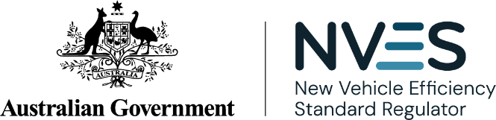

NVES Portal user guide
Empowering industry | Safeguarding integrity | Driving transparency
Version 1.4
February 2026
© Commonwealth of Australia 2026

Ownership of intellectual property rights in this publication
Unless otherwise noted, copyright (and any other intellectual property rights, if any) in this publication is owned by the Commonwealth of Australia (referred to below as the Commonwealth).

Disclaimer
The material contained in this publication is made available on the understanding that the Commonwealth is not providing professional advice, and that users exercise their own skill and care with respect to its use, and seek independent advice if necessary.
The Commonwealth makes no representations or warranties as to the contents or accuracy of the information contained in this publication. To the extent permitted by law, the Commonwealth disclaims liability to any person or organisation in respect of anything done, or omitted to be done, in reliance upon information contained in this publication.

Creative Commons licence

With the exception of (a) the Coat of Arms; (b) the Department of Infrastructure, Transport, Regional Development, Communications, Sport and the Arts photos and graphics; (c) content supplied by third parties; (d) content otherwise labelled; copyright in this publication is licensed under a Creative Commons BY Attribution 4.0 International Licence.

Use of the Coat of Arms
The Department of the Prime Minister and Cabinet (PM&C) sets the terms under which the Coat of Arms is used. Please refer to the Commonwealth Coat of Arms Information and Guidelines | PM&C.

Contact us
This publication is available in PDF format and word format. All other rights are reserved, including in relation to any departmental logos or trade marks which may exist.
For enquiries regarding the licence and any use of this publication, please contact the NVES Regulator:
- Email: NVESRegulator@infrastructure.gov.au
- Website: www.nvesregulator.gov.au

Contents
Ownership of intellectual property rights in this publication 2
Disclaimer 2
Creative Commons licence 2
Use of the Coat of Arms 2
Contact us 2
Contents 3
About this user guide 4
We are here to help 4
Online systems covered in this guide 5
ROVER 5
NVES Portal 5
NVES Unit Registry 6
Accessing the portal 8
If an access denied error messages appears 10
Navigating the portal 11
Dashboard 11
Notifications 13
Vehicles 14
Applications 16
Registry 17
Admin Centre 29
More information coming soon 32
Document Control 32

About this user guide
This user guide has been developed for regulated entities (car manufacturers, suppliers and importers who hold a vehicle type approval) and their authorised users (users) accessing the New Vehicle Efficiency Standard (NVES) Portal (the portal).
The portal was released in September 2025. There have been 2 enhancements to the portal since this time, October 2025 and January 2026.
In the first release (September 2025) the portal allowed users to:
- apply to open a unit registry account, including submitting their FPP declaration
- view their NVES vehicle data as entered on the Register of Approved Vehicles (RAV)
- view their emissions performance over time (referred to as their rolling emissions value)
- view requests for information from us.
In the October 2025 enhancement, users were able to access the new ‘Admin Centre’ in the portal, allowing them to:
- update their Executive Officer details and secondary contact details for their organisation
- switch profiles (if they act on behalf of more than one regulated entity)
- update/give unit registry permissions to other users (only for a unit registry).
In our most recent January 2026 enhancement:
- we can issue interim emissions values (IEVs) and any associated units to entities from February 2026. Users and their entities will be able to see them in the portal.
- entities can manage (transfer or extinguish) their units from February 2026
- entities can self-manage their unit registry permissions through the portal dashboard.
This guide will be updated as more functionality is released.

We are here to help

NVES account managers
For questions or issues with the portal or this user guide, regulated entities and their authorised users can contact their NVES Regulator account manager by:
- Email: NVESRegulator@infrastructure.gov.au
- Phone:
  - From within Australia: 1800 248 610
  - From outside Australia: +61 2 6136 9088.

ROVER support team
Regulated entities experiencing issues managing authority to act permissions or ROVER can contact the department’s ROVER support team by:
- Email: ROVERinfo@infrastructure.gov.au
- Phone:
  - From within Australia: 1800 815 272
  - From outside Australia: +61 2 6136 8006.

More information
Visit our online systems webpage to learn more about the portal and NVES related systems.

Online systems covered in this guide
Regulated entities use multiple systems to meet their obligations under the New Vehicle Efficiency Standard Act 2024 (NVES Act). The 2 main systems are ROVER and the NVES Portal.

ROVER
ROVER is the established administration system for the Road Vehicle Standards Act 2018 (RVSA). It is managed by the Department of Infrastructure, Transport, Regional Development, Communications, Sport and the Arts (the department). You must have an active ROVER account to access the portal.
The Register of Approved Vehicles (RAV) is managed by the department. It is a publicly searchable online database of vehicles that have met the requirements of the RVSA and been approved for provision to the Australian market. All road vehicles must be entered on the RAV, through ROVER before being provided to the market for the first time.
You will enter NVES-specific data on the RAV as part of your obligations under the NVES, and this data will be available in the portal.
You can watch this video to learn how to enter NVES data: ROVER Release 9.3 - NVES fields and the RAV.

NVES Portal
The portal is accessed through ROVER. It is a new central portal where you can fulfil a number of functions to support your compliance obligations under the NVES. You can only access the portal if you have a ROVER authority to act and you have entered NVES covered vehicles on the RAV from 1 July 2025.
The portal first became available from September 2025. From this time, you can apply for an NVES Unit Registry (unit registry) account. The first units were issued in February 2026. You have 12 months from issuance to apply for a unit registry account.
You can watch this video to learn more about the portal’s functionality: NVES Portal overview.

Roles and access in the NVES Portal
Roles and permissions in the portal draw on existing roles and permissions in ROVER.
To access the portal, you must have an active ROVER account and an ‘NVES management’ permission enabled through your authorised user’s ‘authority to act’.

About authority to act
An authority to act allows a user to take actions in ROVER on behalf of another user.
Depending on their level of access, a user with authority to act can, for example, create and submit applications, make payments, manage recalls and RAV entries, or access to the portal. It also allows a user to contribute to another user's application.
Authority to act protects ROVER users’ data by allowing them to control:
- who has access to their personal or organisation profile
- what they can do with that access.
More information can be found in the ROVER guide: Authority to act.
You can assign more than one authorised user in ROVER, including an agent to act on your behalf. If your authority to act expires (this is a default of 2 years) or is removed, you will also lose your NVES management permission and access to the portal.

NVES Unit Registry
The unit registry sits within the portal. We manage and maintain unit registry operations and access to ensure fair participation and to prevent misconduct. It is where NVES units are issued, transferred and extinguished.
The first units were issued in February 2026 for the 2025 performance period. To receive units, you need to beat the requirement for the performance period.
To be able to receive, transfer and extinguish units, you will need to apply to open a unit registry account via the portal. Access to the unit registry is pending upon successful application and approval from the NVES Regulator and passing a fit and proper person (FPP) declaration.
NVES Regulated entities can apply for a unit registry account now.
Important
NVES Regulated entities can apply for a unit registry account now. If your IEV is negative and you have been issued in February 2026, you will have 12 months from issuance to apply for a unit registry account before those units automatically expire.

NVES Unit Registry permissions
Unit registry roles and permissions can be assigned once the account has been opened.
There are 4 main permission types for unit registry accounts:
- Registry viewer: can only view unit transactions and unit balances. If assigned this permission a user cannot hold any other permission.
- Transfer initiator: can view the unit registry and initiate unit transactions for their account.
- Transfer authoriser: can view the unit registry and authorise unit transactions created by a different user. They cannot authorise a unit transaction they make. They will then submit the authorised transaction to the regulator.
- Registry account admin: can view the unit registry and add or remove users to the unit registry account.
These permissions allow you to undertake a variety of actions. You can hold more than one permission, unless you have been allocated as a ‘registry viewer’, in which case you cannot hold any other permission.
While one user may hold both ‘Transfer Initiator’ and ‘Transfer Authoriser’ roles, they cannot authorise the transfers they have initiated.
The roles can be assigned in the unit registry once the account has been opened.
If you are interested in buying or selling units, you can nominate a unit trading contact by emailing your NVES account manager at NVESRegulator@infrastructure.gov.au. The details of the unit trading contact will be shared with other entities who are interested in unit trading. For more information, see How units are traded | New Vehicle Efficiency Standard Regulator.

ROVER, portal and unit registry roles and access
The below diagram shows how the roles and access work across ROVER, the portal and unit registry.
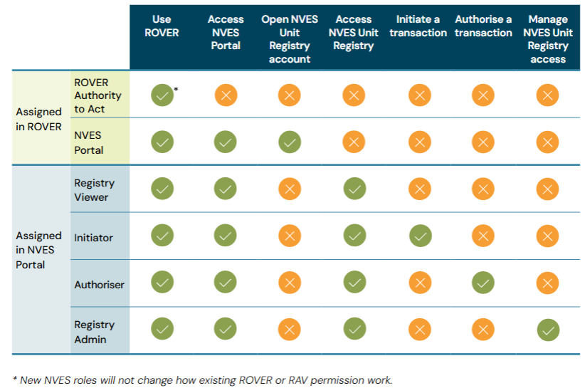
* New NVES roles will not change how existing ROVER or RAV permissions work.

Accessing the portal
The following steps outline how you can access the portal and get your NVES management permission enabled for you and authorised user(s).

Before you begin
Do you have an active ROVER account?
To access the portal, you must have an active ROVER account. If you don’t, follow the steps outlined on the ROVER website: Welcome to ROVER.
Do you know who your ROVER account administrator is?
Your ROVER account administrator will need to grant you authority to act to enable your access to the portal. To check who your ROVER account admin is you can either ask relevant people your company or contact the ROVER support team.
Have you entered an NVES covered vehicle since 1 July 2025?
You can only access the portal if you have a ROVER authority to act and you have entered NVES covered vehicles on the RAV since 1 July 2025.

- Login to your ROVER account using your credentials. If you don’t know your credentials, contact the ROVER support team.
- In ROVER, click on the icon for ‘Authority to act’ from the row of icons in the top banner.
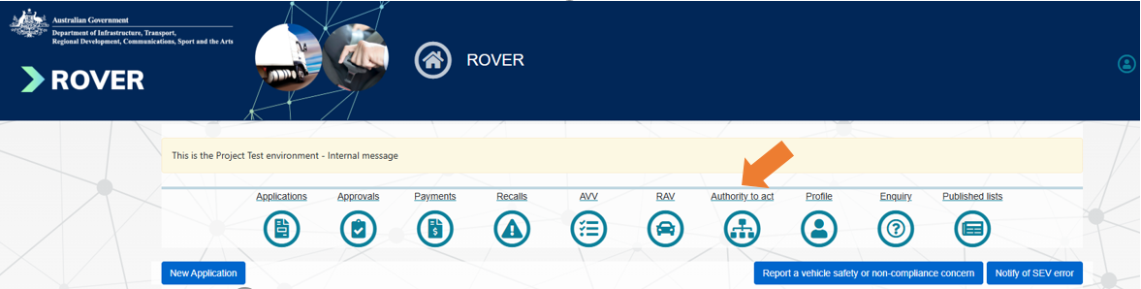

- Your ROVER account admin will need to assign an NVES authority to act in ROVER by clicking on ‘Update Authority to Act’ for your entity. The process for granting or requesting an NVES authority to act is the same as any ROVER authority to act function.
- Your ROVER account admin can then add the ‘NVES management’ permission from the authority to act function list into as many of your users’ profiles as required. There is no limit to how many users can be assigned access to the portal.
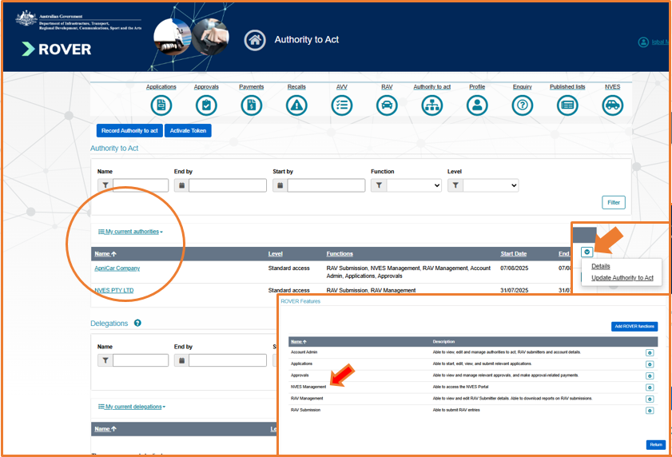

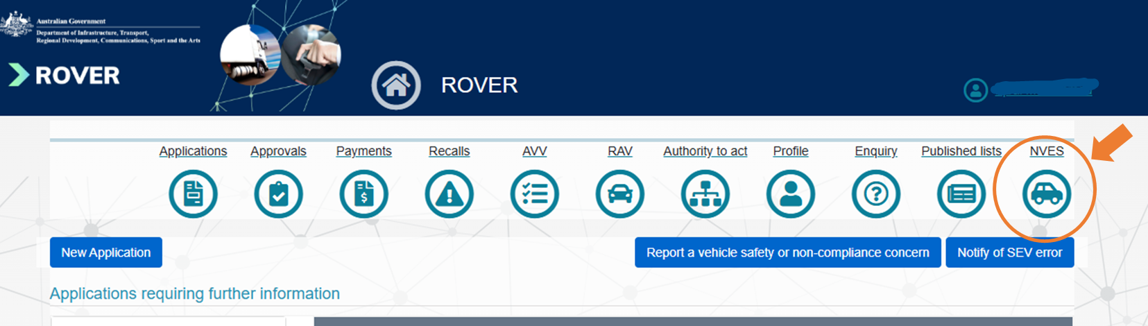

- Once your NVES management permission has been assigned, you will see the NVES icon appear on the far right of the ROVER banner, and you will become an authorised user in the portal. If the NVES icon doesn’t appear, contact the ROVER support team.
- Click on the NVES icon to go to the portal.

If an access denied error messages appears
If an error message appears saying ‘Access denied to the NVES Portal’, there are 3 potential causes:
- Organisation role check failed
A ROVER user who does not have the NVES management function for any regulated entity is given a direct link to the portal. If you see this message, contact your organisation’s ROVER account admin to see if you have been given the NVES management permission.

- Vehicle type approval holder check failed
Only regulated entities have access to the portal. If your organisation is not recognised in ROVER as an NVES regulated entity, you will see this message.
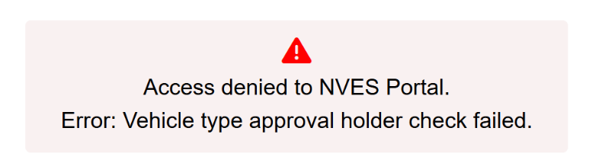

- Register of Approved Vehicles (RAV) entry check failed
If your organisation has not entered an NVES covered vehicle on the RAV since 1 July 2025, you will see this message:
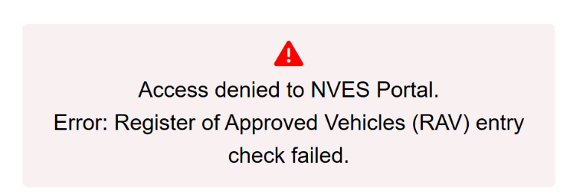

We’re here to help
If you receive an error message you can contact your NVES account manager or email NVESRegulator@infrastructure.gov.au to help resolve it.
Alternatively, you can contact the ROVER support team if you do not have an NVES account manager.

Navigating the portal

Dashboard
Once you and your authorised users(s) have gained access to the portal, it will display the dashboard.
You will be able to see your name and the regulated entity you represent on the top right-hand corner.
In the portal you will be able to:
- apply for a unit registry account
- view how the entity’s fleet is performing against emissions targets
- view the entity’s NVES-specific data entered on the RAV
- download reconciliation reports
- see notifications.
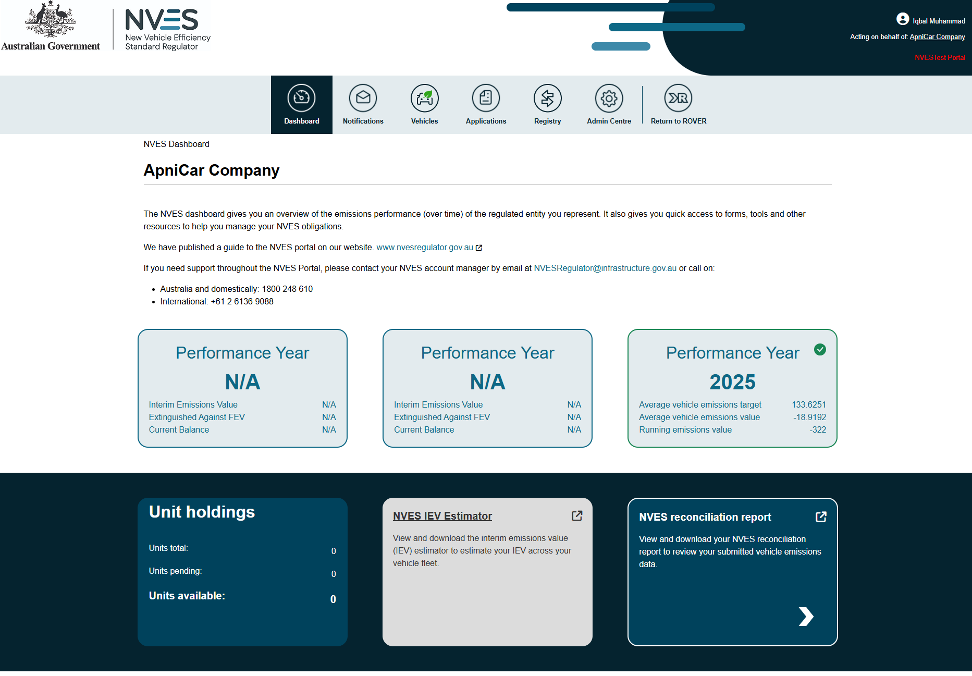

Switch profiles (act for different entities)
If you have an NVES authority to act for multiple regulated entities (for example, if you are an agent), you can switch between entity profiles by clicking on the name of the regulated entity you represent on the top right-hand corner of the page.
The ‘Select Your Profile’ page will appear and show the ROVER entities you have an NVES authority to act for.
If you are missing an entity, check you have an NVES authority to act for that entity. If an entity is still missing, you can contact your NVES account manager or email NVESRegulator@infrastructure.gov.au.
Important: you can only access the portal for an entity for which you have authority to act, and which has entered an NVES covered vehicle on the RAV since 1 July 2025.
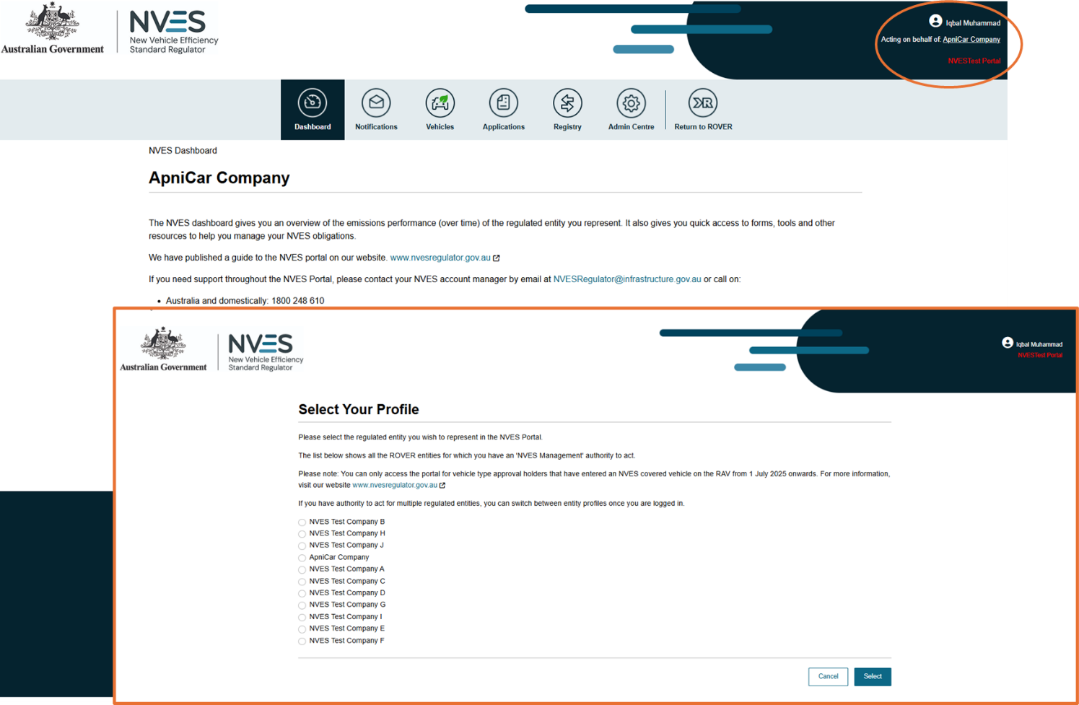

Notifications
The notifications page can be accessed by clicking on the second icon in the portal’s banner.
This page allows you and your authorised user(s) to view notifications and requests for information.
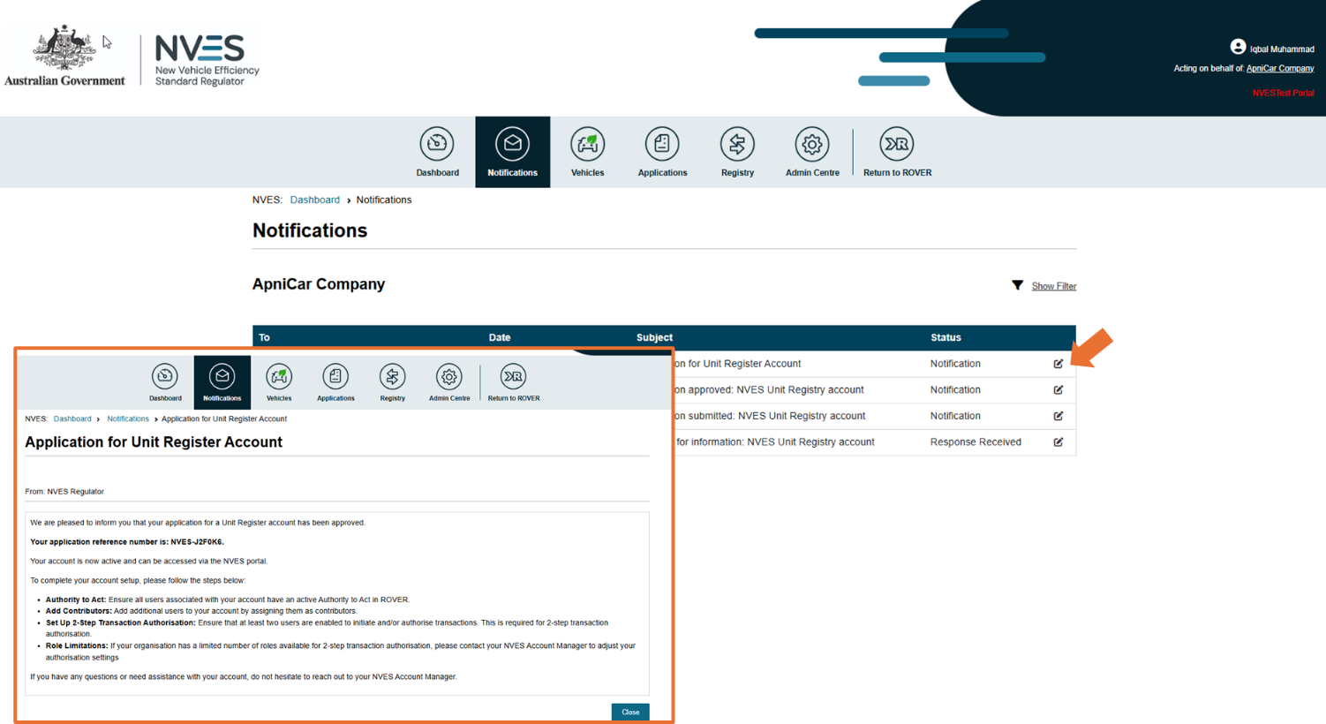

Important: Responding to requests for information
You cannot respond to requests for information from the regulator in the portal at this stage.
Responses must be emailed to NVESRegulator@infrastructure.gov.au. This feature will be added in a later release.

Vehicles
The Vehicles page can be accessed by clicking on the third icon in the portal’s banner.
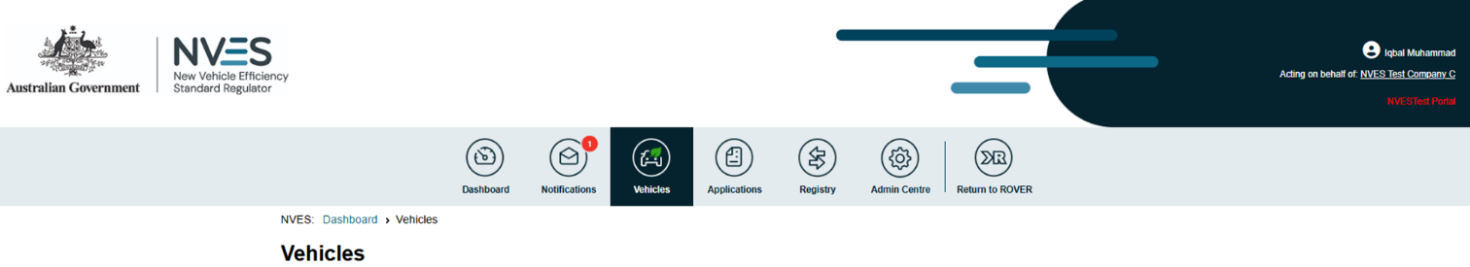

It shows the NVES vehicles your entity has entered on the RAV. You can track and reconcile these vehicles here.
Under ‘NVES data from RAV entries’ you can:
- view information about each covered vehicle, such as NVES vehicle type, carbon dioxide (CO₂) emissions, mass in running order (MIRO) and the emissions target
- sort and filter the vehicles shown in the table by date (most recent to least recent – this is the default setting), Vehicle Identification Number (VIN), RAV entry date (date range), approval number, vehicle type, make or model.
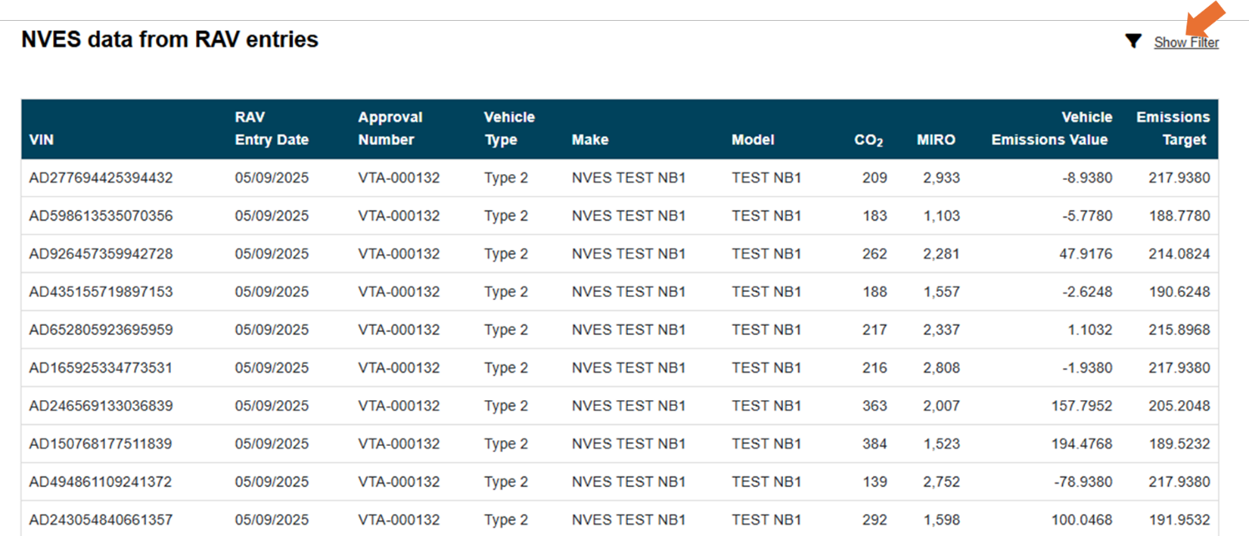
To do this, click on ‘sort filter’ above the table on the top right-hand side. You can then choose how to filter your search.
Once completed, you can export your data into an Excel file (up to 5,000 rows). If you need to export more than the system limit of 5,000 rows, we recommend filtering your date range to smaller batches within the limit and conduct multiple exports.
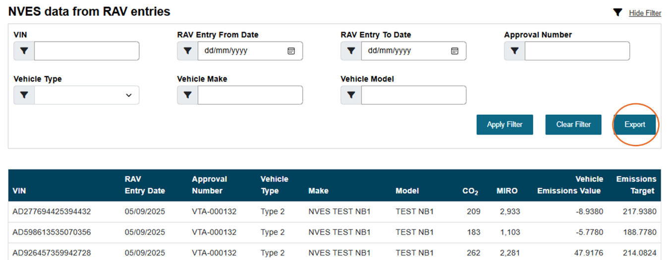

What is a vehicle type approval holder?
A vehicle type approval holder is the individual or company granted permission to provide a specific type of vehicle to the Australian market under a vehicle type approval as per the RVSA.
More information can be found in the department’s guide to vehicle type approvals.

Applications
The applications page can be accessed by clicking on the fourth icon in the portal’s banner.
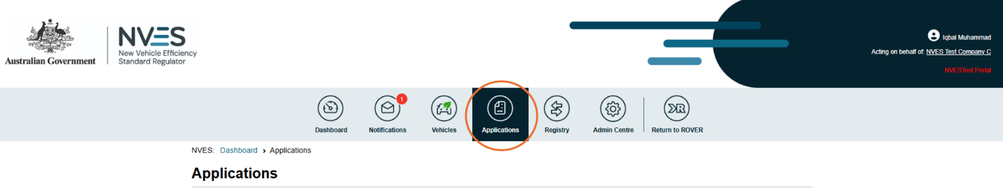
The applications page shows all NVES applications in one place. On this page you can apply for a unit registry account.
In a future enhancement to the portal, functionality will be available for you to apply for units due to a late RAV correction or a destroyed vehicle(s).
To apply for a unit registry account, navigate to the ‘Apply for an NVES Unit Registry Account’ tile. This will take you to the application page.
The application page has 4 sections you will need to complete:
- your organisation details including your executive officer
- your details, including your secondary contact (if applicable)
- an fit and proper (FPP) declaration about your organisation
- review your application and submit.

Important: You can only apply once for a unit registry account
Applying for a unit registry account can only be completed by one user for each entity.

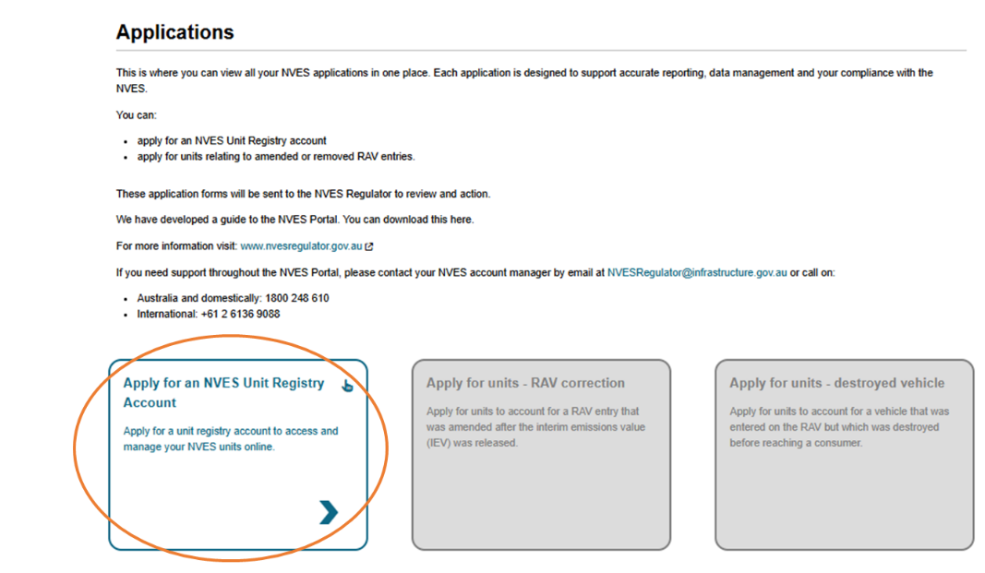

Registry
The registry page can be accessed by clicking on the fifth icon in the portal’s banner.

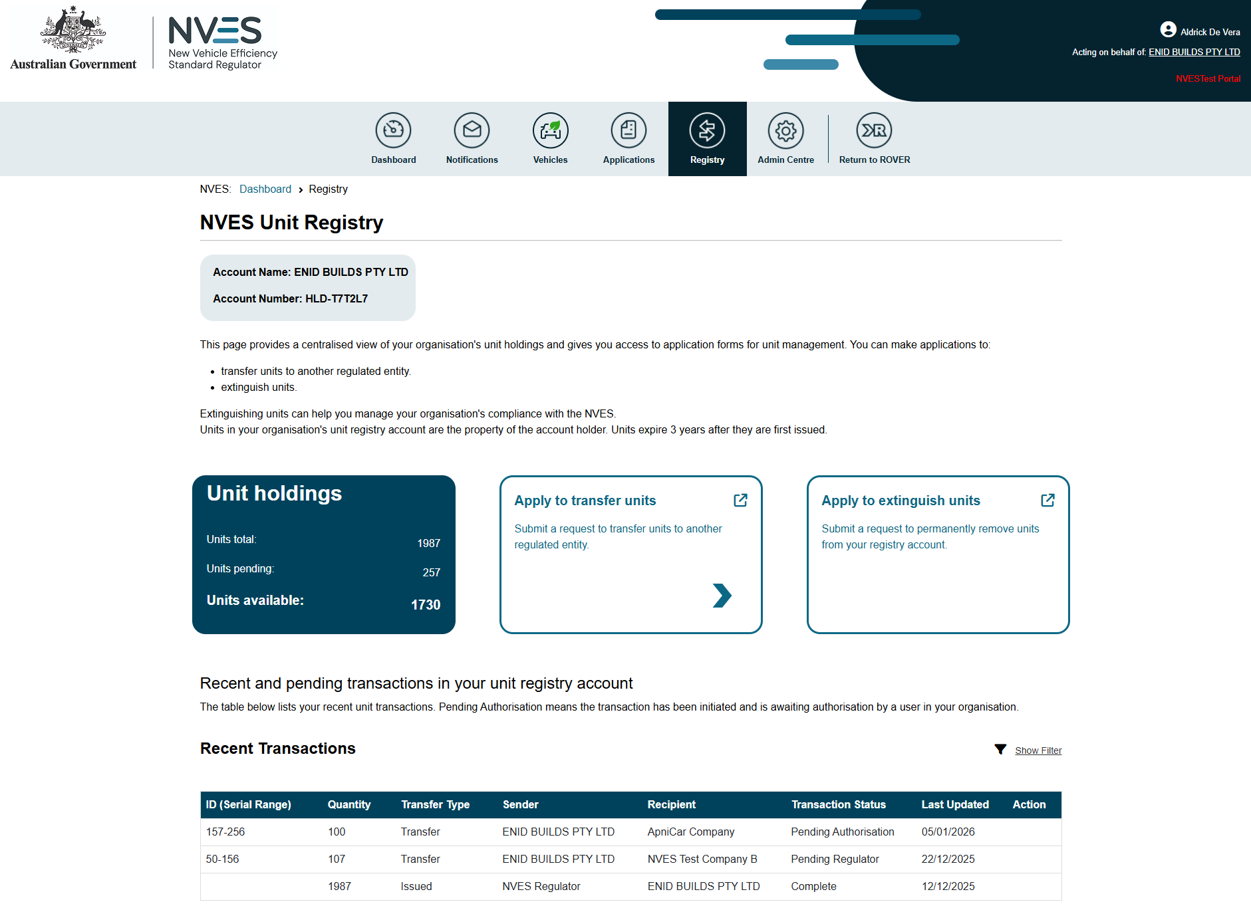
On the registry page, you can:
- check the unit holdings of the regulated entity, including any units pending and available units
- apply to transfer or extinguish units if you have the transfer initiator role
- see recent transactions for the regulated entity.

Apply to transfer units
To apply to transfer units, navigate to the ‘Apply to transfer units’ title. This will take you to the application page.
The application page has 4 sections you will need to complete:
- Before you begin with important information about initiating a transfer.
- Recipient details to provide important details about the regulated entity receiving the units.
- Select units which allows you to select the units you would like to transfer.
- Review your application and submit.
Only users with an ‘Initiator’ permission for an entity can apply to transfer units.
The below are screenshots of each of the 4 sections required for completion.
Before you begin
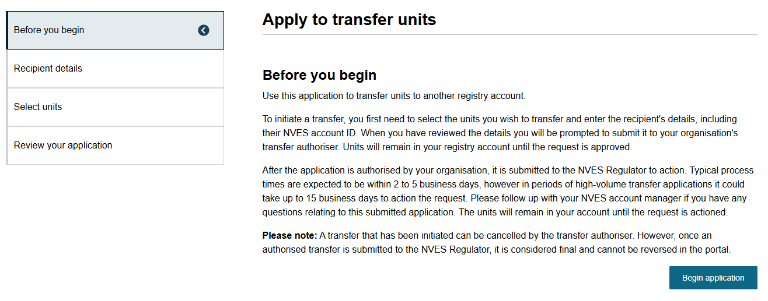
Recipient details
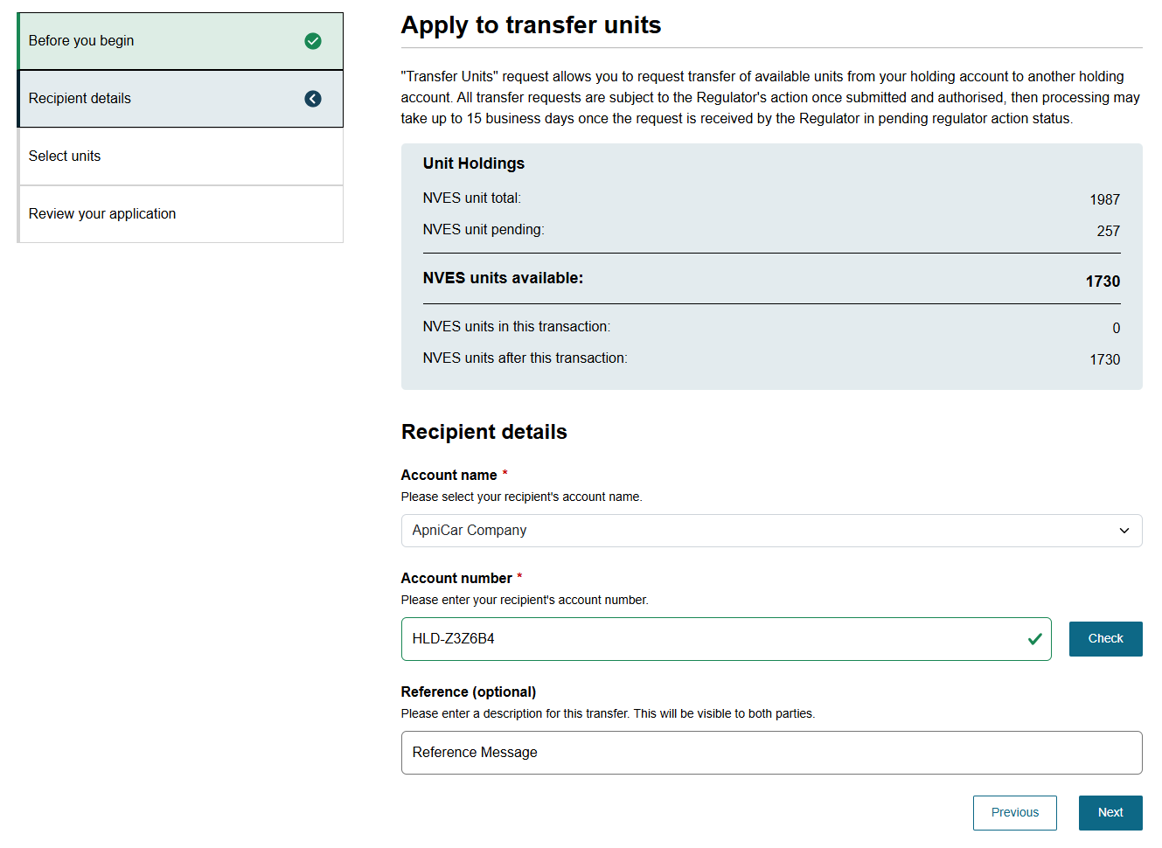
Select units
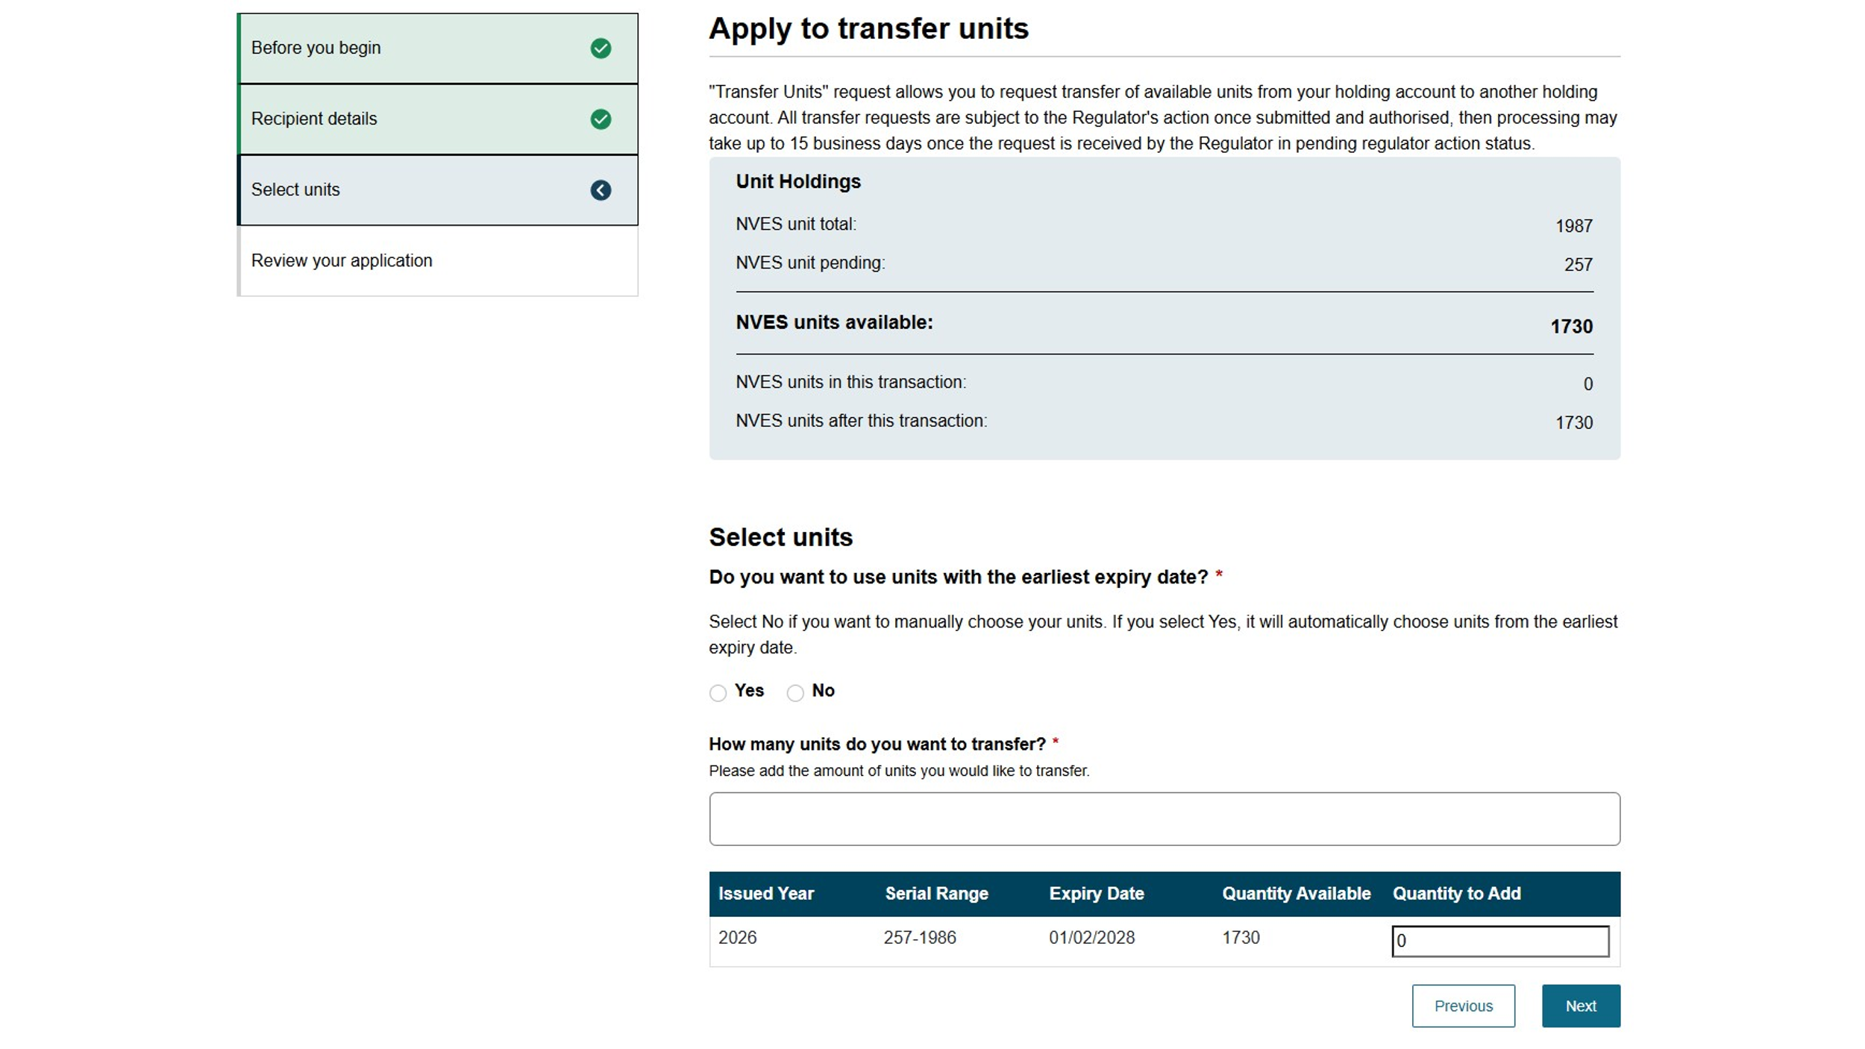
Review your application
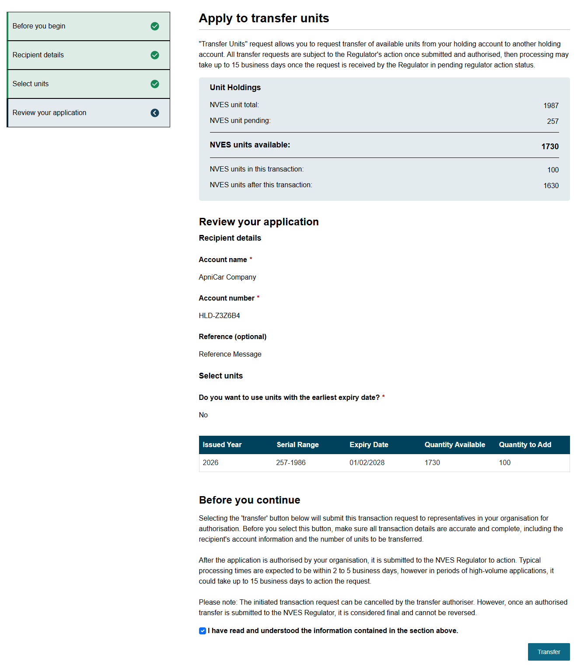
Post application submission
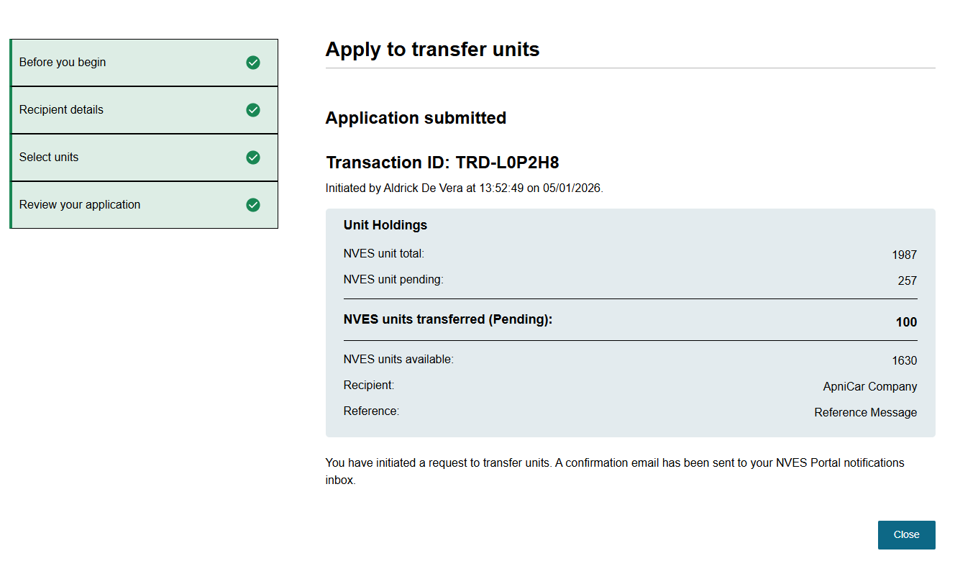

Authorising the transfer of units
Only users with an ‘Authoriser’ permission for a regulated entity can authorise a unit transaction initiated by an ‘Initiator’ in the same entity.
To open a pending authorisation application, navigate to it under recent transactions on the ‘Registry’ page.
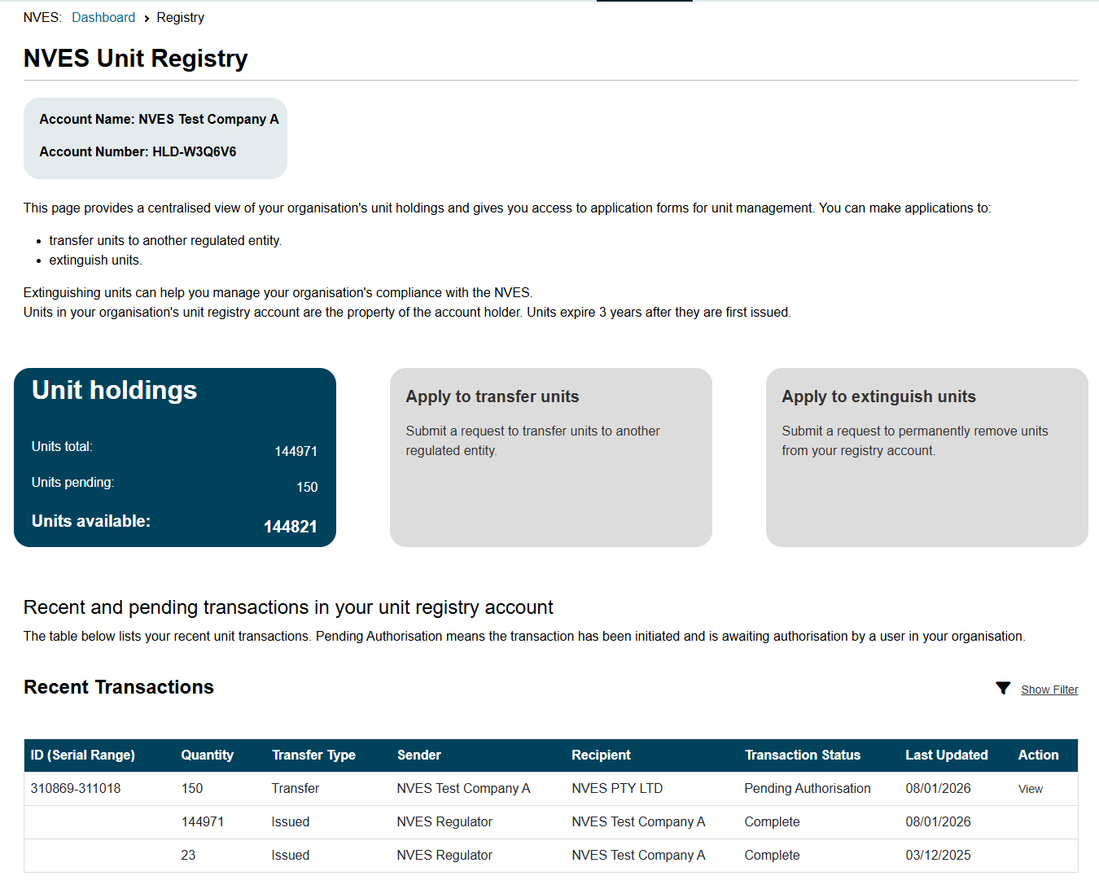
After checking the transaction details, you can either authorise or deny the transfer request.
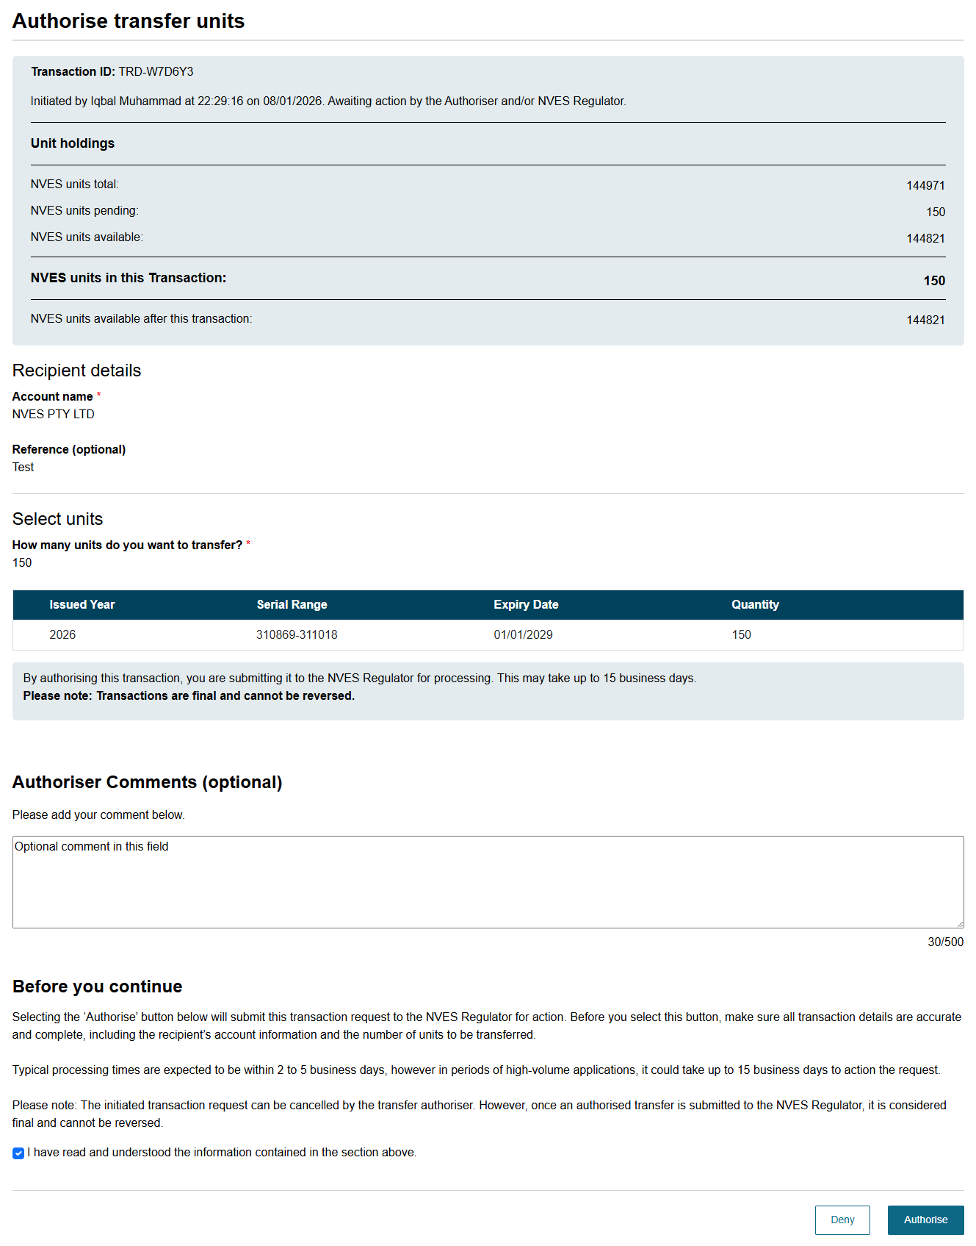
The transaction will go to the Regulator for approval after authorisation.

Apply to extinguish units
To apply to extinguish units, navigate to the ‘Apply to extinguish units’ section on the Registry page
The application process is similar to the ‘Apply to Transfer Units’ process. The application has 4 sections for you to read and complete:
- Before you begin section with important information on how to initiate an extinguishment of units.
- Extinguishment details section where you can see your available units and for what year you would like to extinguish them against.
- Select units section allows you to select the units you would like to extinguish.
- Review your application and submit.
Before you begin
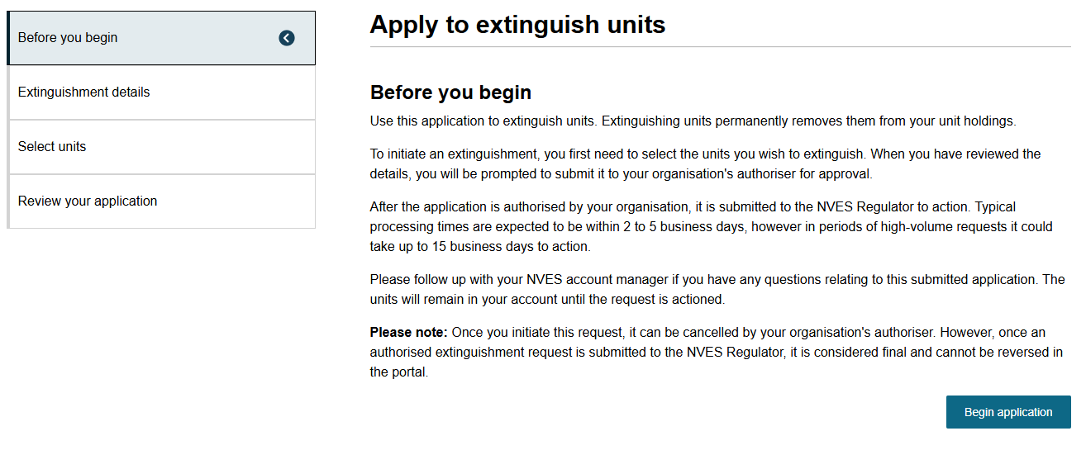

Extinguishment details
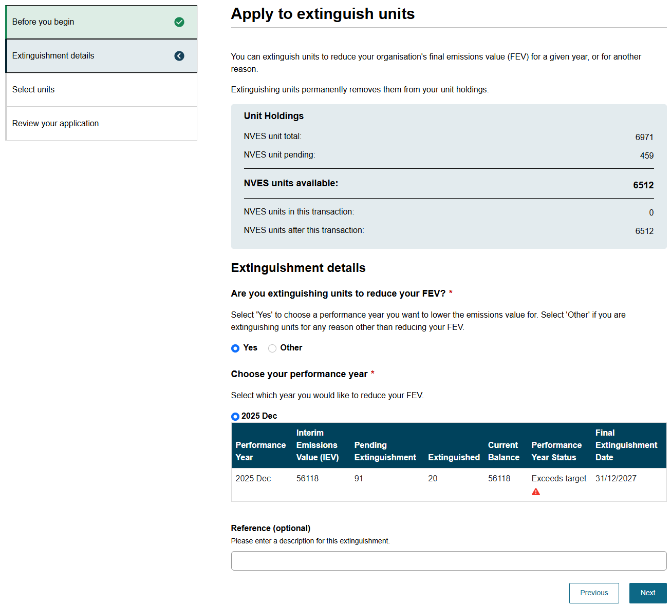

Select units
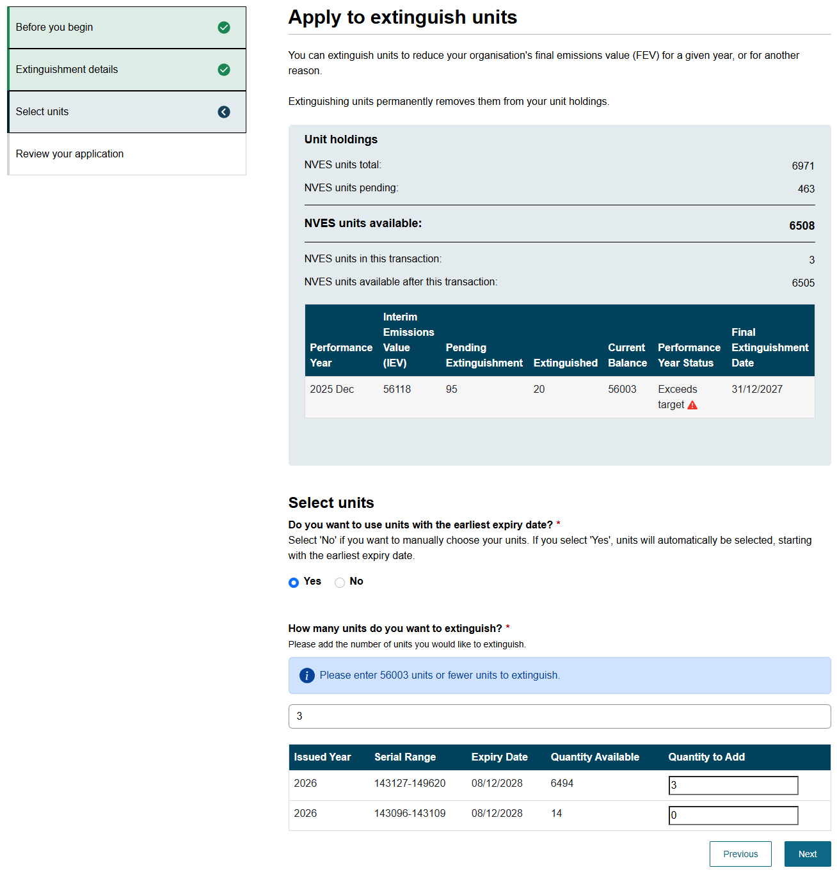

Review you application
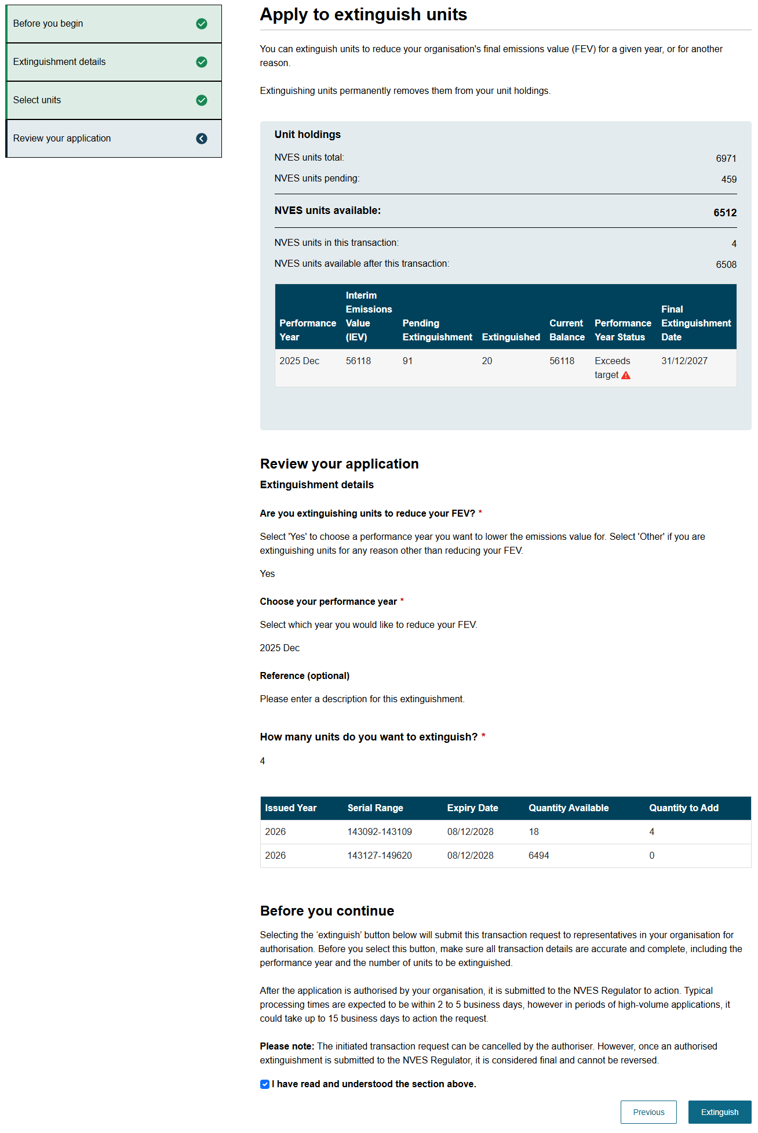

Post application submission
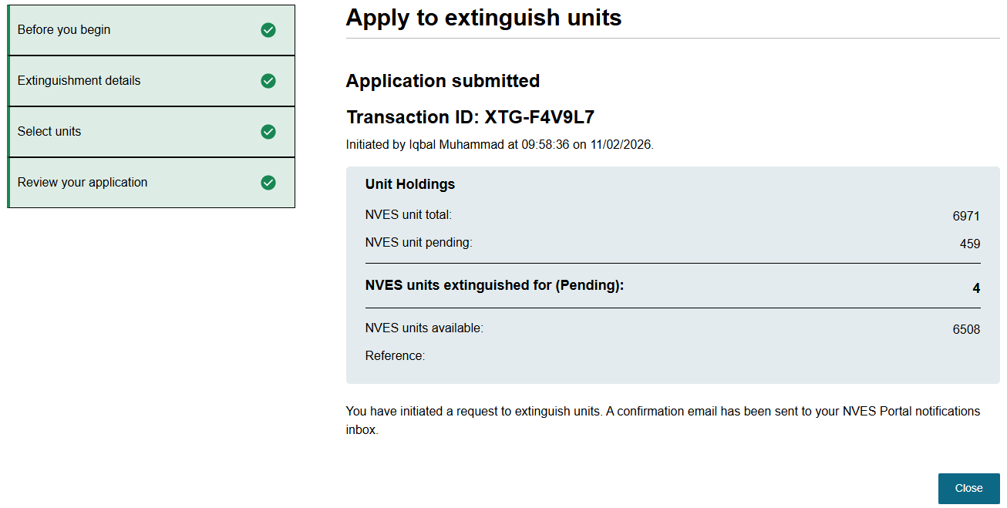

Authorise extinguishment of units
Only users with an ‘Authoriser’ permission for a regulated entity can authorise a unit extinguishment initiated by an ‘Initiator’.
To open a pending authorisation application, you need to navigate to it under recent transactions on the ‘Registry’ page.
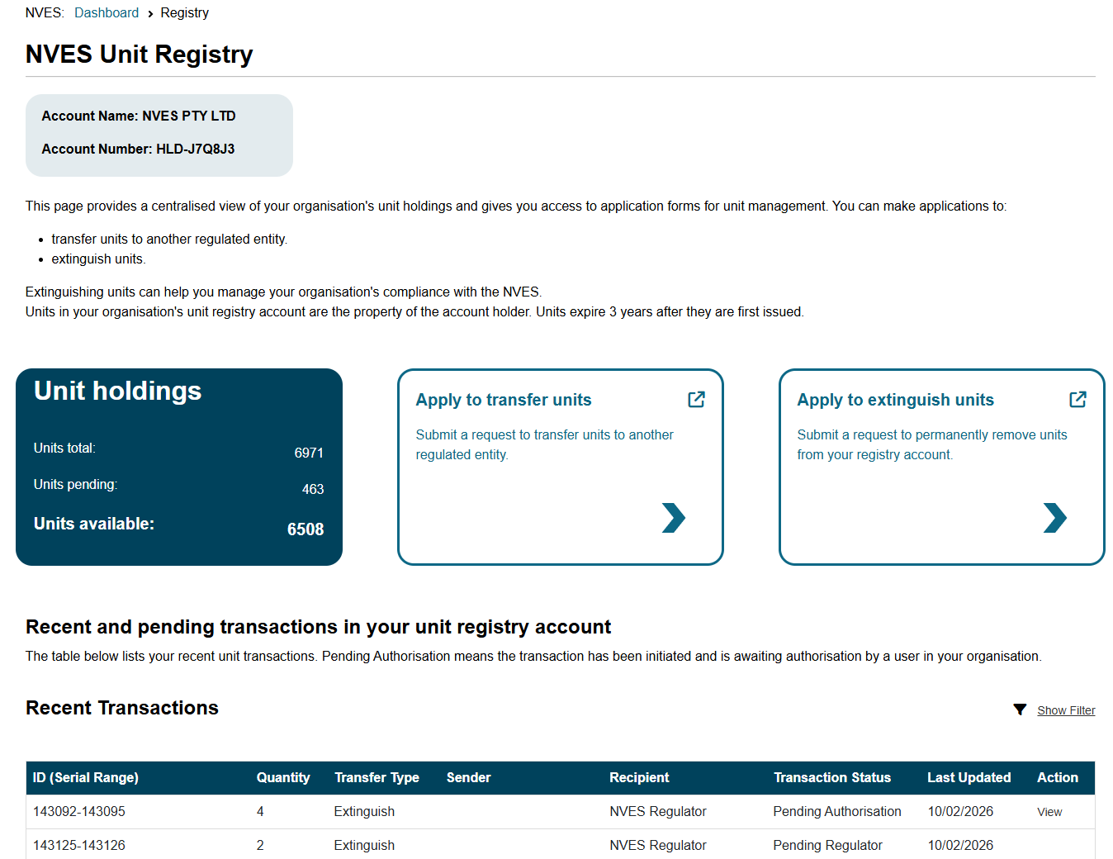
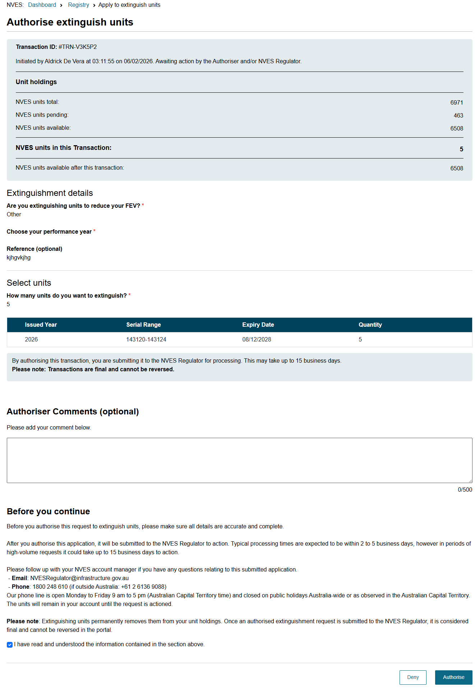

Important: Pending transactions authorisation risk
Transactions will fail if the ‘Initiator’ or ‘Authoriser’ permissions are revoked while the transaction is still in progress.
If an initiated transaction is still with an ‘Authoriser’ of the regulated entity, they can reject the pending transaction and may initiate a new transaction.
However, if an authorised transaction is with the regulator, you need to contact your NVES Account Manager by emailing at NVESRegulator@infrastructure.gov.au to request cancellation of the transaction.

Admin Centre
The admin centre page can be accessed by navigating to the sixth icon in the portal’s banner.

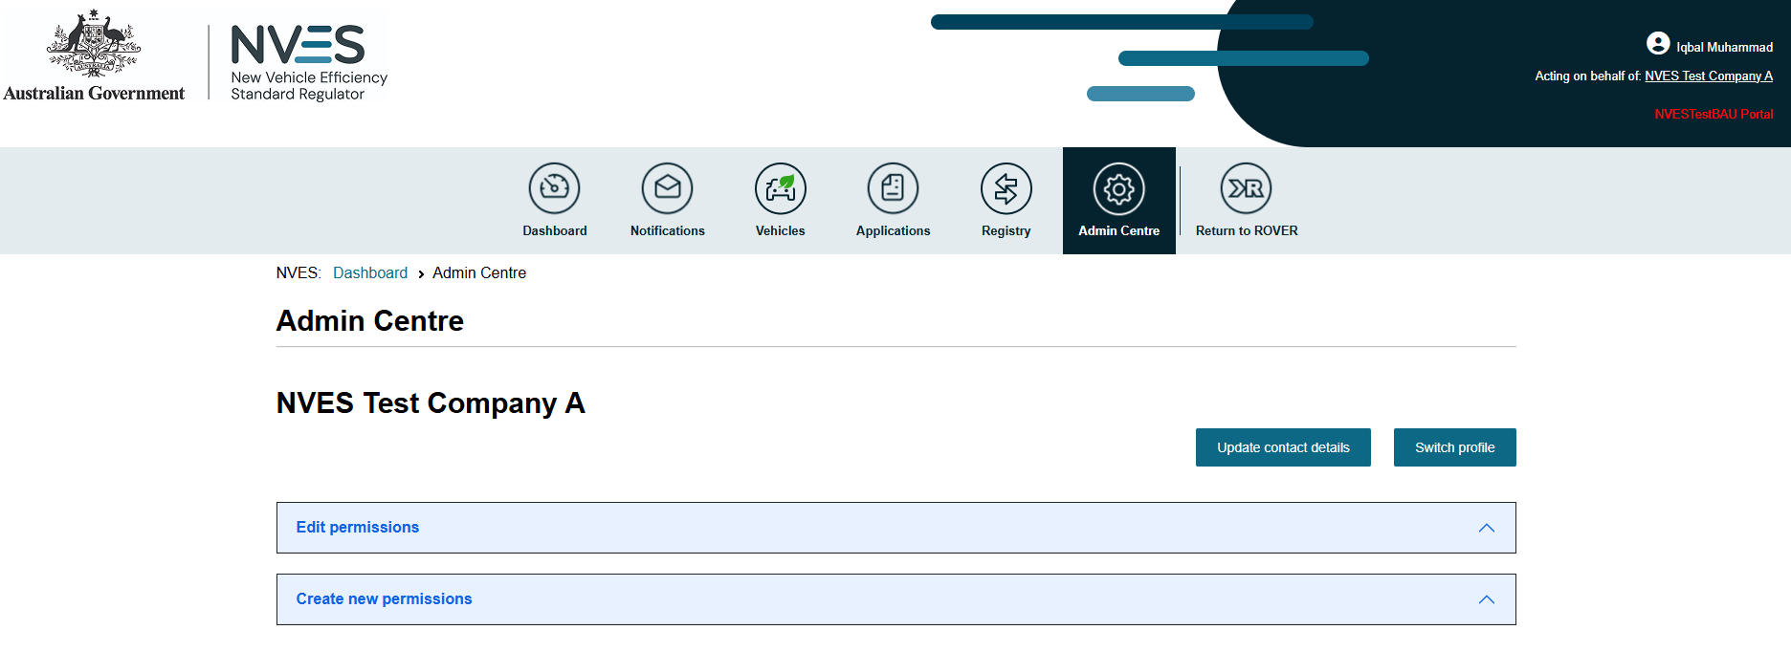
On the admin centre page, you can update contact details of the regulated entity, executive or an optional secondary contact, and switch profile (act for different entities).
On this page, you can also give permissions to other users and manage permissions of existing authorised users.
If you provide a secondary contact for an entity, then email notifications will also be sent to the entity’s secondary contact.
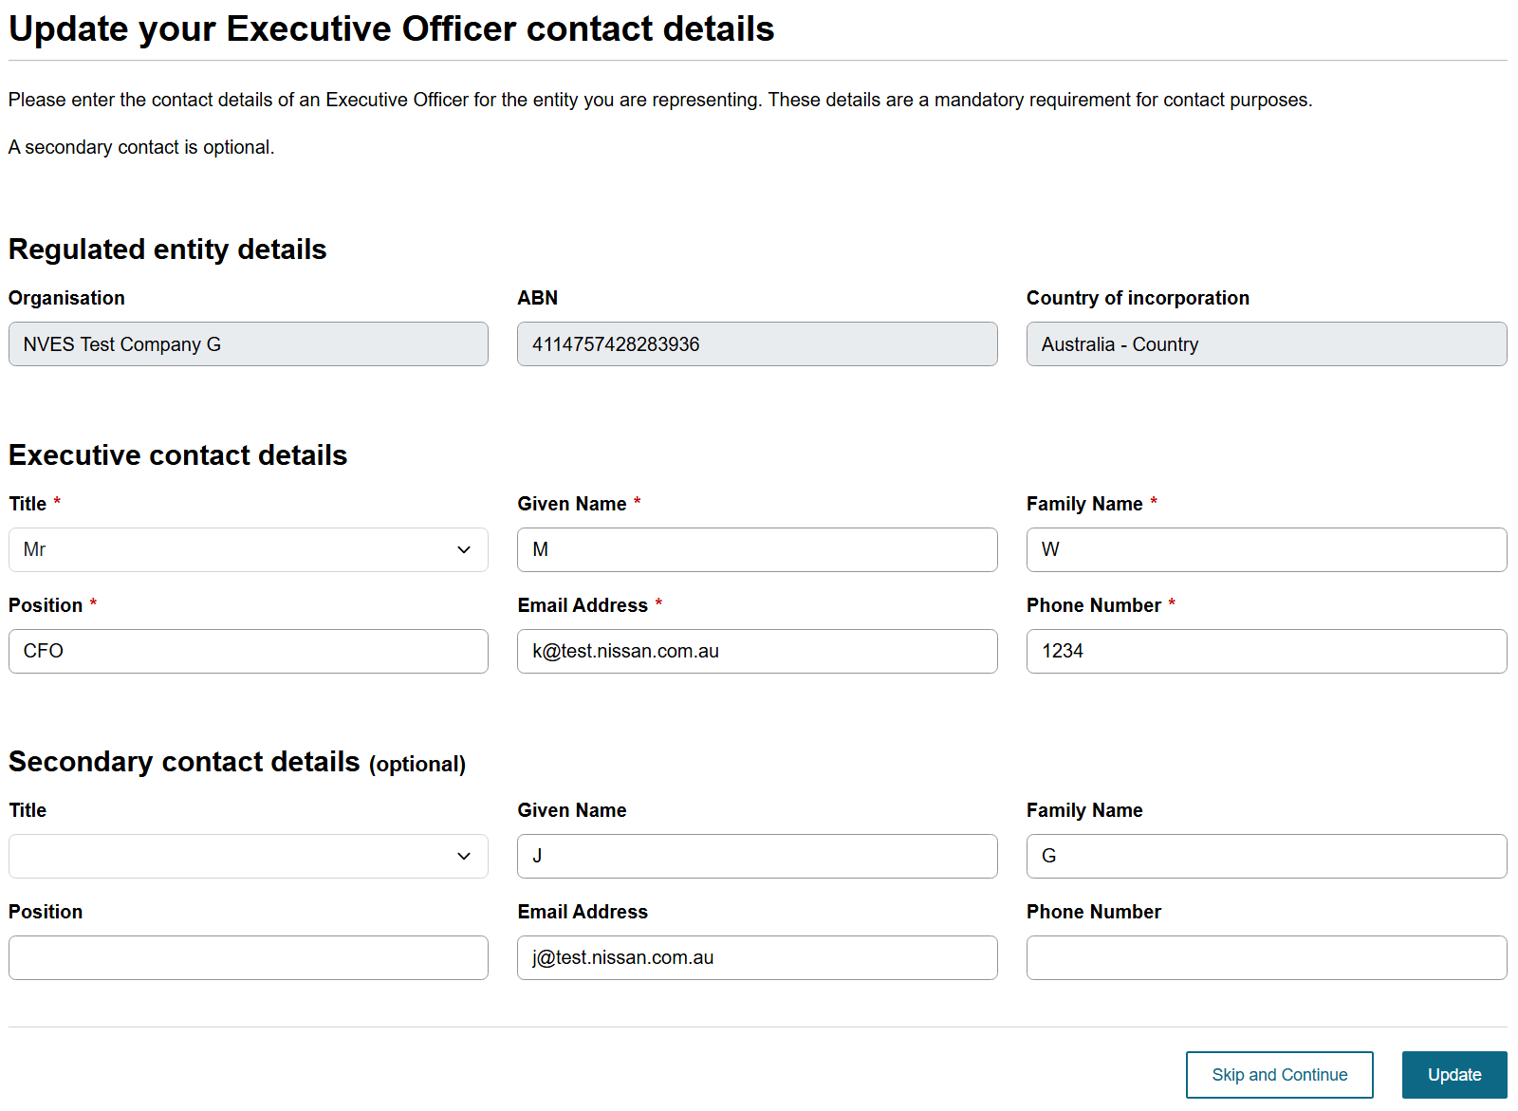
Only users with a Registry Admin role of an approved registry account can create new permissions to invite an existing user with an authority to act for the regulated entity. The permission has a start date and an optional end date. You can assign permissions to one or more roles for the unit registry account:
- Transfer Initiator
- Transfer Authoriser
- Registry Viewer
- Registry Account Administrator.
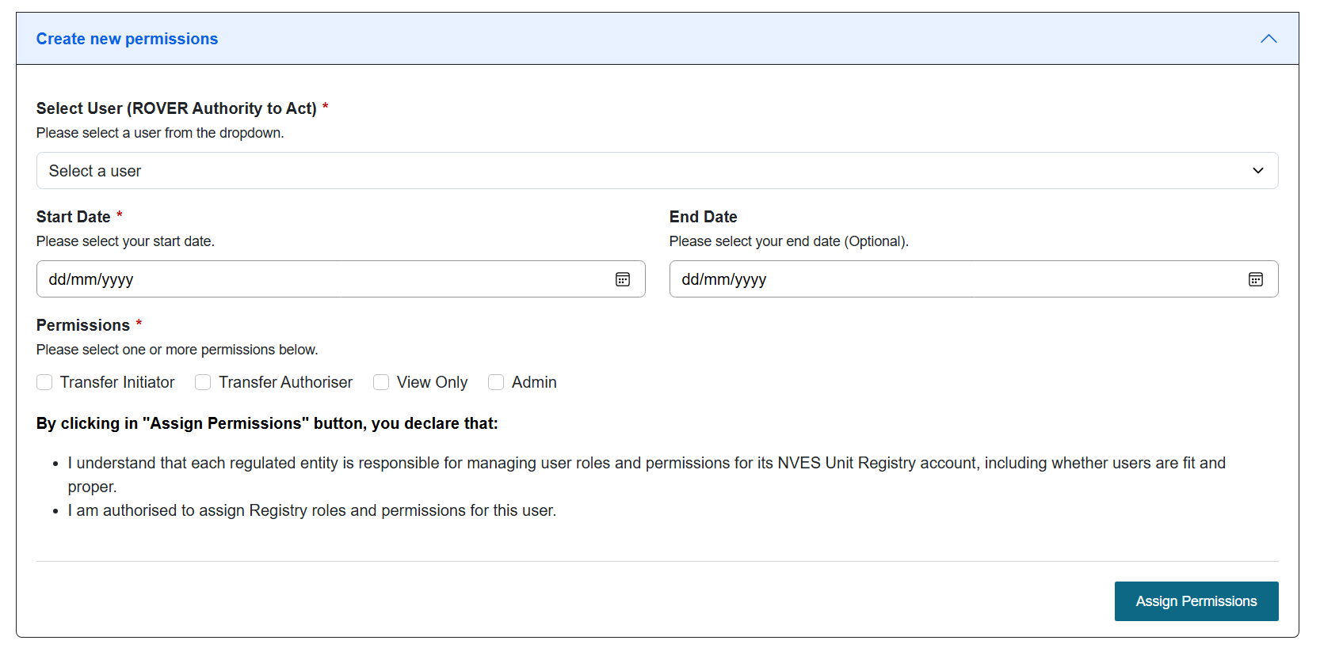
See the ROVER, portal and unit registry roles and access section on page 7 for more details.
The invitee can accept the invitation to gain access to the profile of the entity.
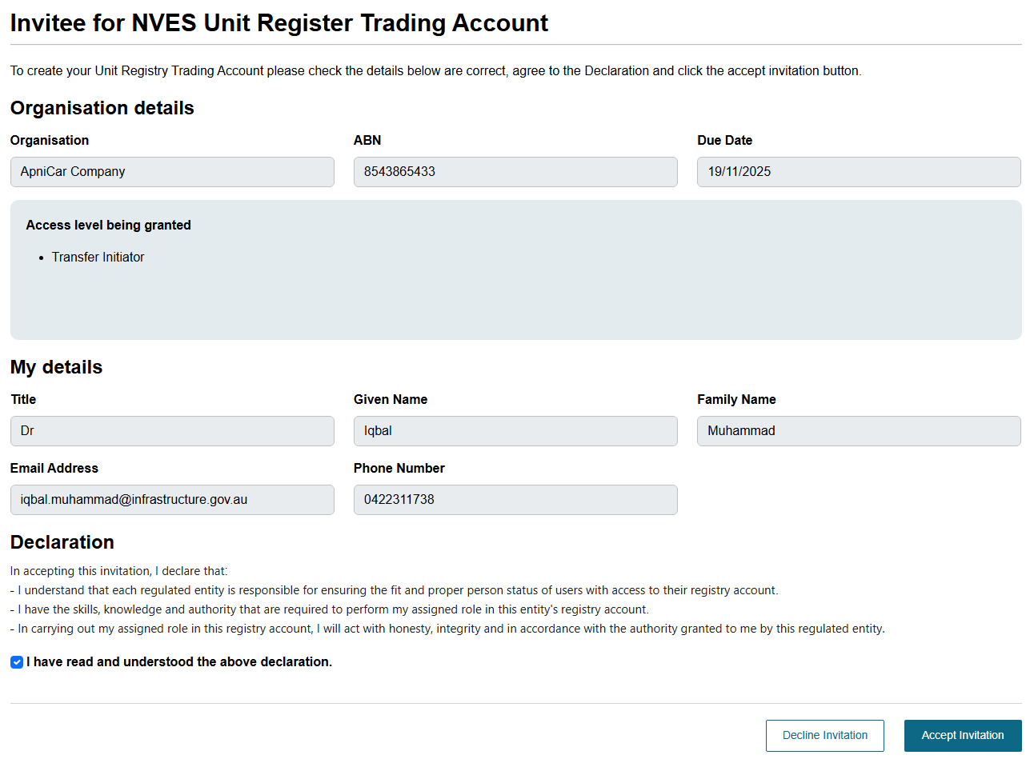
Only users with a ‘Registry Admin role’ of an approved registry account can manage account permissions of existing authorised users.

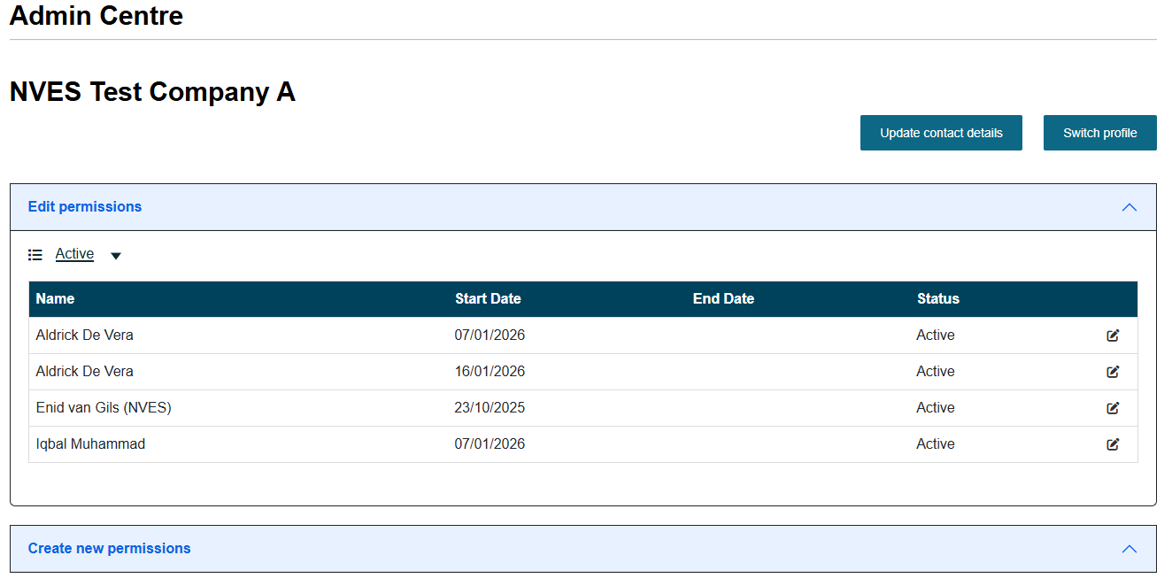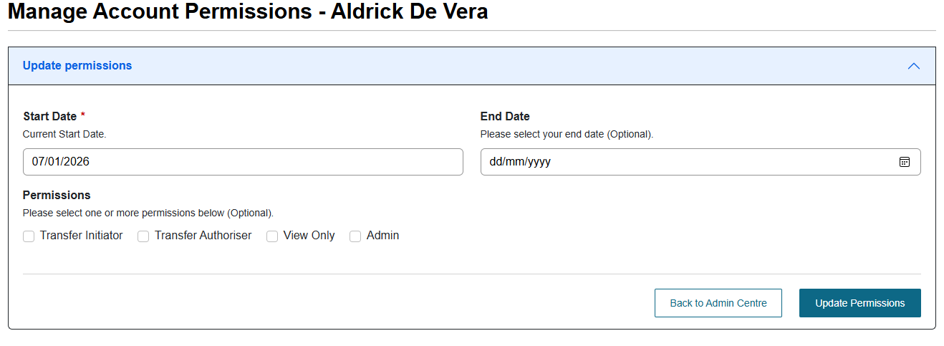

More information coming soon
This guide will be updated as more functionality is released over the coming months.
We will keep regulated entities updated on when portal releases will happen and what functionality is being released.

Document Control
Refer to the following table for the approver and latest version of this document.
Version | Release date | Reason for update
1.0 | Sept 2025 | Initial release of document.
1.1 | October 2025 | Update for NVES Portal release 2.1.
1.2 | December 2025 | Update fit and proper person content.
1.3 | January 2026 | Update for NVES Portal release 3.1
1.4 | February 2026 | Update for NVES Portal release 3.2

