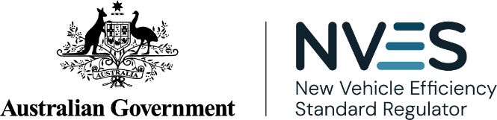

NVES Portal user guide
Empowering Industry | Safeguarding Integrity | Driving Transparency
Version 1.8
August 2026

© Commonwealth of Australia 2026

Ownership of intellectual property rights in this publication
Unless otherwise noted, copyright (and any other intellectual property rights, if any) in this publication is owned by the Commonwealth of Australia (referred to below as the Commonwealth).

Disclaimer
The material contained in this publication is made available on the understanding that the Commonwealth is not providing professional advice, and that users exercise their own skill and care with respect to its use, and seek independent advice if necessary.
The Commonwealth makes no representations or warranties as to the contents or accuracy of the information contained in this publication. To the extent permitted by law, the Commonwealth disclaims liability to any person or organisation in respect of anything done, or omitted to be done, in reliance upon information contained in this publication.

Creative Commons licence

With the exception of (a) the Coat of Arms; (b) the Department of Infrastructure, Transport, Regional Development, Communications, Sport and the Arts photos and graphics; (c) content supplied by third parties; (d) content otherwise labelled; copyright in this publication is licensed under a Creative Commons BY Attribution 4.0 International Licence.

Use of the Coat of Arms
The Department of the Prime Minister and Cabinet (PM&C) sets the terms under which the Coat of Arms is used. Please refer to the Commonwealth Coat of Arms Information and Guidelines | PM&C.

Contact us
This publication is available in PDF format and word format. All other rights are reserved, including in relation to any departmental logos or trade marks which may exist.
For enquiries regarding the licence and any use of this publication, please contact the NVES Regulator:
- Email: NVESRegulator@infrastructure.gov.au
- Website: www.nvesregulator.gov.au

Contents

About this user guide 5
Online systems covered in this guide 5
ROVER 5
NVES Portal 5
Roles and access in the portal 5
About authority to act 6
NVES Unit Registry 6
NVES Unit Registry permissions 6
Unit trading contact list 7
ROVER, portal and unit registry roles and access 7
Accessing the portal 8
Before you begin 8
Troubleshooting for ‘access denied’ error messages 10
We’re here to help 10
Navigating the portal 11
Dashboard 11
Switch profiles (act for different entities) 13
Notifications 14
Vehicles 15
What is a vehicle type approval holder? 16
Applications 17
Applying for a NVES Unit Registry Account 17
Applying for non-standard issuance of units 22
Non-standard issuance: RAV adjustment 23
Non-standard issuance: destroyed vehicles 23
How to apply 23
Using the CSV template 24
Registry 26
Unit holdings 27
Pending transactions table 27
Emissions performance table 27
Apply to transfer units 28
Authorising the transfer of units 32
Apply to extinguish units 34
Authorise extinguishment of units 38
Admin Centre 41
Update your Executive Officer contact details 42
Manage account permissions of an existing user 42
Remove NVES Unit Registry account 44
We are here to help 45
NVES account managers 45
ROVER support team 45
More information 45
Document Control 46

About this user guide
This user guide has been developed for regulated entities (car manufacturers, suppliers and importers who hold a vehicle type approval) and their authorised users (users) accessing the New Vehicle Efficiency Standard (NVES) Portal (the portal).

Online systems covered in this guide
Regulated entities use multiple systems to meet their obligations under the New Vehicle Efficiency Standard Act 2024 (NVES Act). The 2 main systems are ROVER and the NVES Portal.

ROVER
ROVER is the established administration system for the Road Vehicle Standards Act 2018 (RVSA). It is managed by the Department of Infrastructure, Transport, Regional Development, Communications, Sport and the Arts (the department). You must have an active ROVER account to access the portal.
The Register of Approved Vehicles (RAV) is managed by the department. It is a publicly searchable online database of vehicles that have met the requirements of the RVSA and been approved for provision to the Australian market. All road vehicles must be entered on the RAV, through ROVER, before being provided to the market for the first time.
You will enter NVES-specific data on the RAV as part of your obligations under the NVES, and this data will be available in the portal.
You can watch this video to learn how to enter NVES data: ROVER Release 9.3 - NVES fields and the RAV.

NVES Portal
The portal is accessed through ROVER. It is a central portal where you can fulfil a number of functions to support your compliance obligations under the NVES.
You can only access the portal if you have a ROVER authority to act and you have entered NVES covered vehicles on the RAV since 1 July 2025.
The portal first became available in September 2025, allowing users to apply for an NVES Unit Registry (unit registry) account.
The first units were issued in February 2026. Entities that have received units have 12 months from date of issue to apply for a unit registry account.
You can watch NVES Portal overview to learn more about the portal’s functionality.

Roles and access in the portal
Roles and permissions in the portal draw on existing roles and permissions in ROVER.
To access the portal, you must have an active ROVER account and an ‘NVES management’ permission enabled through your authorised user’s ‘authority to act’.

About authority to act
An authority to act allows a user to take actions in ROVER on behalf of another user.
Depending on their level of access, a user with authority to act can, for example, create and submit applications, make payments, manage recalls and RAV entries, or access to the portal. It also allows a user to contribute to another user's application.
Authority to act protects ROVER users’ data by allowing them to control:
- who has access to their personal or organisation profile
- what they can do with that access.
More information can be found in the ROVER guide: Authority to act.
You can assign more than one authorised user in ROVER, including an agent to act on your behalf. If your authority to act expires (this is a default of 2 years) or is removed, you will also lose your NVES management permission and access to the portal.

NVES Unit Registry
The unit registry is accessed through the portal. We manage and maintain unit registry operations and access to ensure fair participation and to prevent misconduct. It is where NVES units are issued, transferred and extinguished.
The first units were issued in February 2026 for the 2025 performance period. To receive units, you need to beat the emissions target for the performance period.
To be able to receive, transfer and extinguish units, you will need to apply to open a unit registry account through the portal. Access to the unit registry is dependent upon:
- successful application and approval from the regulator
- passing a fit and proper person (FPP) declaration.
Find out more about the NVES Unit Registry on our online systems webpage.
Important
You can apply for a unit registry account now. You must have opened a unit registry account by January 2027 to receive units issued to you in February 2026.
If you beat your emissions target (resulting in a negative IEV), units for the 2025 performance period were issued to you in February 2026.
They must be claimed within 12 months of issue by registering for a unit registry account. After which they will automatically expire.

NVES Unit Registry permissions
Unit registry roles and permissions can be assigned once the account has been opened.
There are 4 main permission types for unit registry accounts:
- Registry viewer: can only view unit transactions and unit balances. If assigned this permission a user cannot hold any other permission.
- Transfer initiator: can view the unit registry and initiate unit transactions for their account.
- Transfer authoriser: can view the unit registry and authorise unit transactions created by a different user. They cannot authorise a unit transaction they make. They will then submit the authorised transaction to the regulator.
- Registry account admin: can view the unit registry and add or remove users to the unit registry account.
These permissions allow you to undertake a variety of actions. You can hold more than one permission, unless you have been allocated as a ‘registry viewer’, in which case you cannot hold any other permission.
While one user may hold both ‘Transfer Initiator’ and ‘Transfer Authoriser’ roles, they cannot authorise the transfers they have initiated.
The roles can be assigned in the unit registry once the account has been opened.

Unit trading contact list
If you are interested in buying or selling units, you can nominate a unit trading contact by emailing your NVES account manager at NVESRegulator@infrastructure.gov.au. The details of the unit trading contact will be shared with other entities who are interested in unit trading.
Find out more about how units are traded.

ROVER, portal and unit registry roles and access
The below diagram shows how the roles and access work across ROVER, the portal and unit registry.
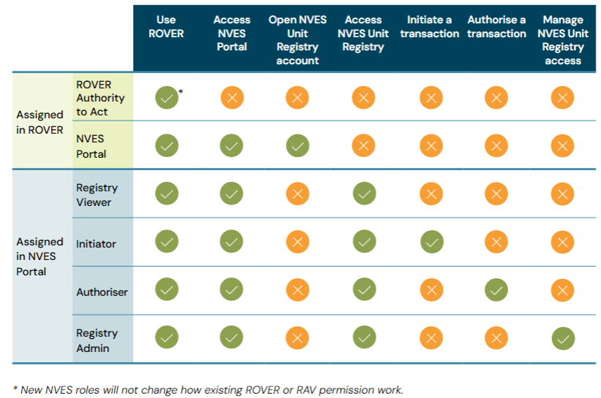
* New NVES roles will not change how existing ROVER or RAV permissions work.

Accessing the portal
The following steps outline how you can access the portal and enable your NVES management permission for you and your entity’s authorised user(s).

Before you begin
Do you have an active ROVER account?
To access the portal, you must have an active ROVER account. If you don’t, follow the steps outlined on the ROVER website: Welcome to ROVER.
Do you know who your ROVER account administrator is?
Your ROVER account administrator will need to grant you authority to act to enable your access to the portal. To check who your ROVER account admin is you can either ask relevant users in your company or contact the ROVER support team.
Have you entered an NVES covered vehicle since 1 July 2025?
You can only access the portal if you have a ROVER authority to act and you have entered NVES covered vehicles on the RAV since 1 July 2025.

- Login to your ROVER account using your credentials. If you don’t know your credentials, contact the ROVER support team to retrieve them.
- In ROVER, click on the icon for ‘Authority to act’ from the row of icons in the top banner. The below screenshot outlines this.
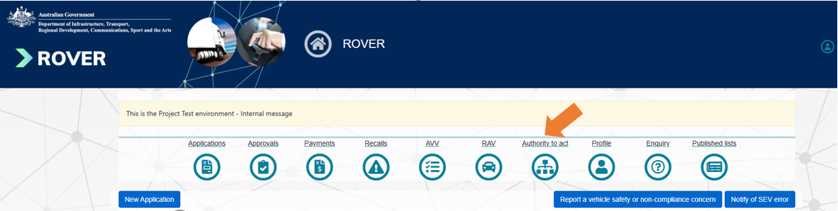

- Your ROVER account admin will need to assign an NVES authority to act in ROVER by clicking on ‘Update Authority to Act’ for your entity.
  - The process for granting or requesting an NVES authority to act is the same as any ROVER authority to act function.
- Your ROVER account admin can add the ‘NVES management’ permission from the authority to act function list into as many of your users’ profiles as required. There is no limit to how many users can be assigned access to the portal. See screenshot below.
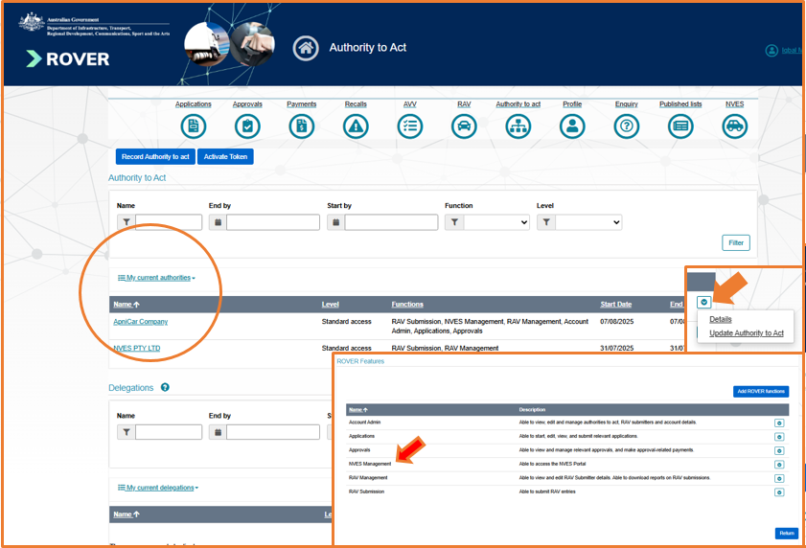

- Once your NVES management permission has been assigned, you will see the NVES icon appear on the far right of the ROVER banner, and you will become an authorised user in the portal. If the NVES icon doesn’t appear, contact the ROVER support team. See screenshot below.
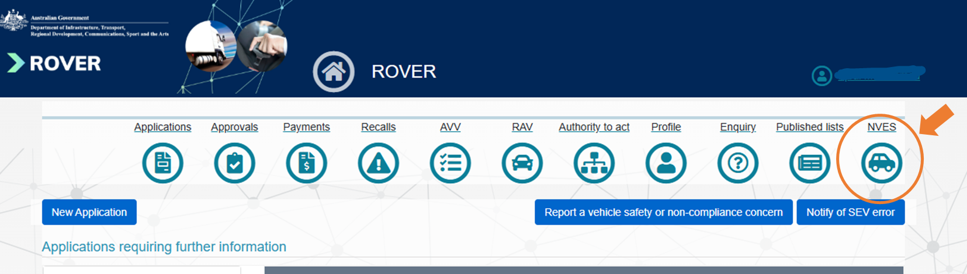
- Click on the NVES icon to gain access to the portal.

Troubleshooting for ‘access denied’ error messages
If an ‘Access denied to the NVES Portal’ error message appears, there are 3 potential causes:
- Organisation role check failed
This is when a ROVER user who does not have the ‘NVES management’ permission enabled for an entity is given a direct link to the portal. If you receive this message, contact your organisation’s ROVER account admin to check if you are authorised to receive it.

- Vehicle type approval holder check failed
Only regulated entities have access to the portal. If your organisation is not recognised in ROVER as an NVES regulated entity, you will receive this message:
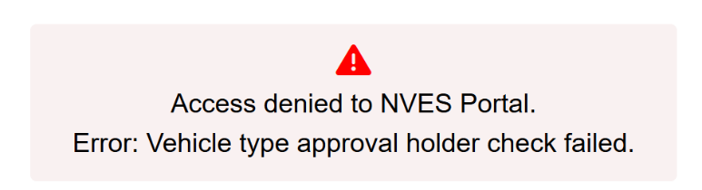

- Register of Approved Vehicles (RAV) entry check failed
If your organisation has not entered an NVES covered vehicle on the RAV since 1 July 2025, you will receive this message:
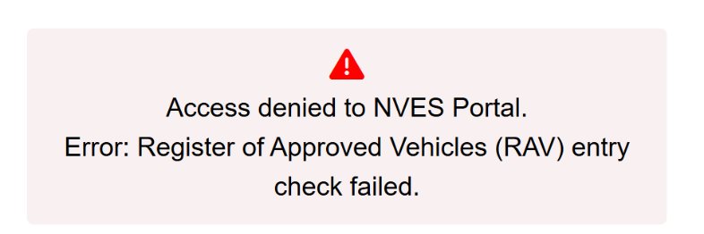

We’re here to help
If you receive an error message you can contact your NVES account manager or email NVESRegulator@infrastructure.gov.au to help resolve it.
Alternatively, you can contact the ROVER support team if you do not have an NVES account manager.

Navigating the portal

Dashboard
Once you and your authorised user(s) have gained access to the portal, the portal dashboard will be available.
Your name and the regulated entity you represent will be on the top right-hand corner. See screenshot below.
In the portal you will be able to:
- apply for a unit registry account
- view how the entity’s fleet is performing against emissions targets
- view unit holdings of the entity
- view any request for information and pending registry notifications
- access the NVES reconciliation report for your submitted vehicle emissions data
- see notifications.
Note: dashboard for your organisation is likely to look different from the below screenshot and will be showing information relevant to current status of your organisation.

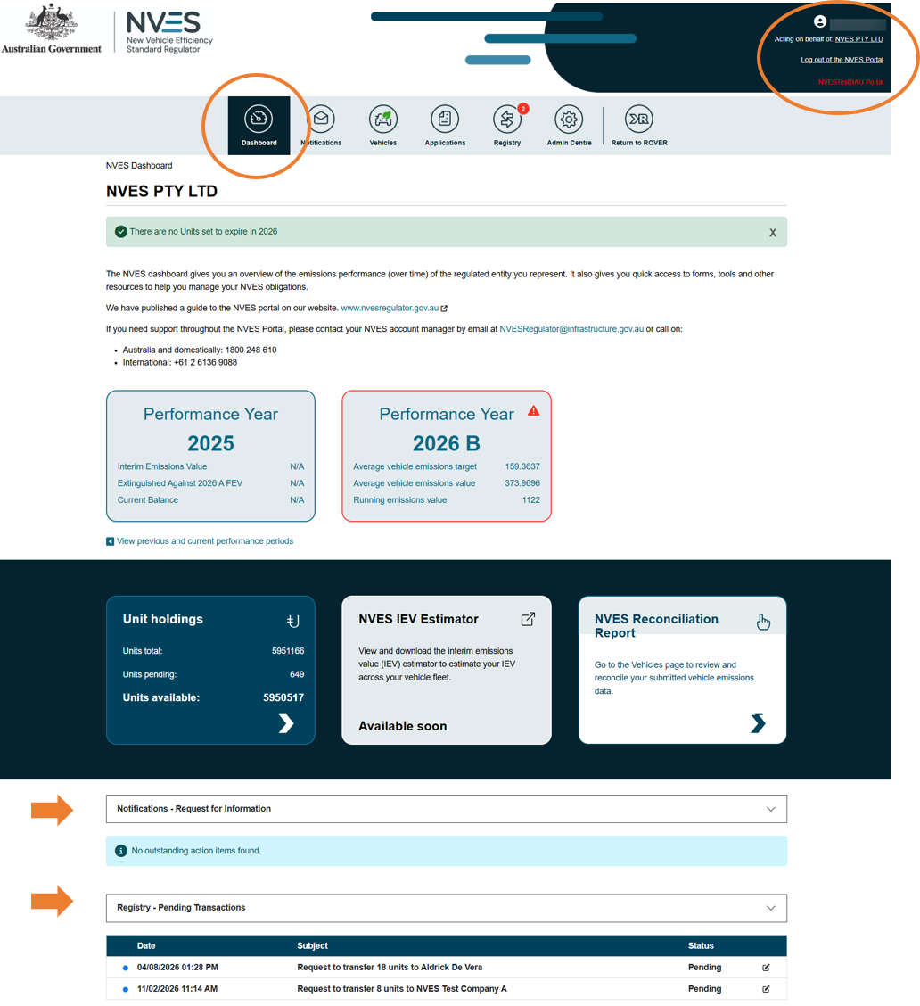

Switch profiles (act for different entities)
If you have an NVES authority to act for multiple regulated entities (for example, if you are an agent), you can switch between entity profiles by clicking on the name of the regulated entity you represent on the top right-hand corner of the page. See screenshot below.
The ‘Select Your Profile’ page will appear and show the ROVER entities you have an NVES authority to act for.
If you are missing an entity, check you have an NVES authority to act for that entity in ROVER. If an entity is still missing, you can contact your NVES account manager or email NVESRegulator@infrastructure.gov.au.
Important
You can only access the portal for an entity you have an NVES authority to act for.
The entity must have entered an NVES covered vehicle on the RAV since 1 July 2025.
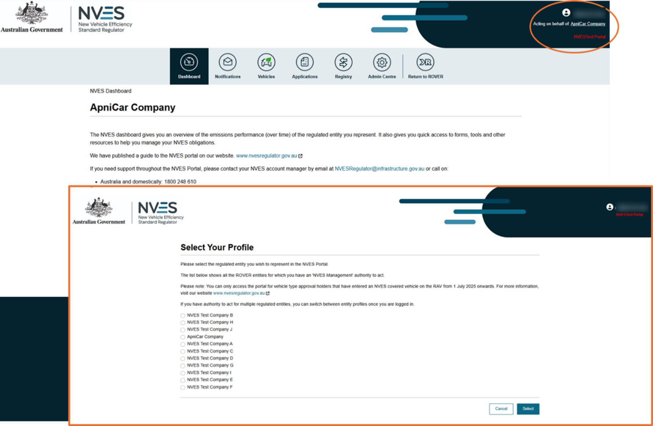

Notifications
The notifications page can be accessed by clicking on the second icon in the portal’s banner.
This page allows you and your authorised user(s) to view notifications and requests for information (RFI) from the regulator. See screenshot below.
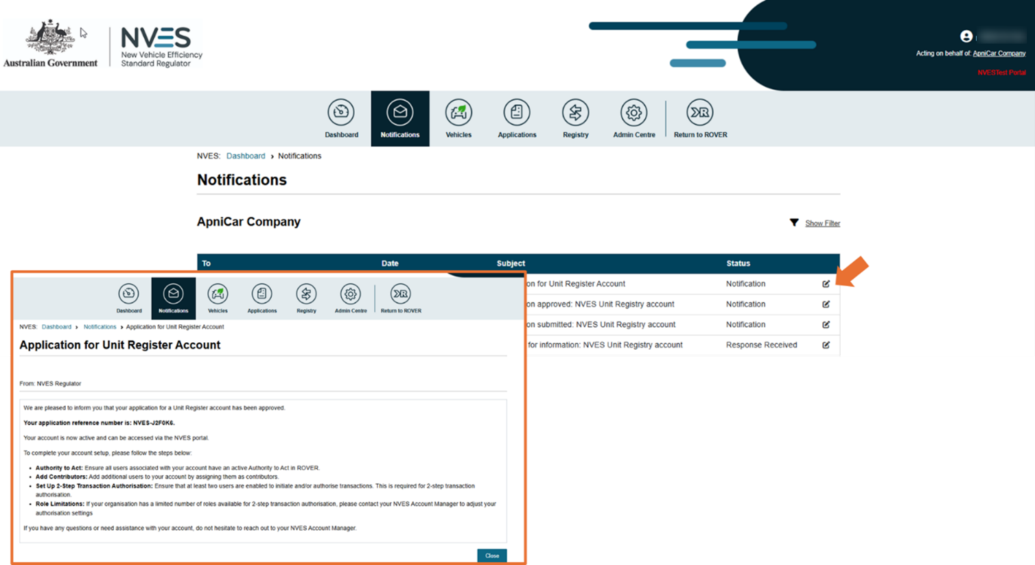
You can also respond to RFIs from the NVES Regulator in the portal, including an option to upload documents in your response. See screenshot below.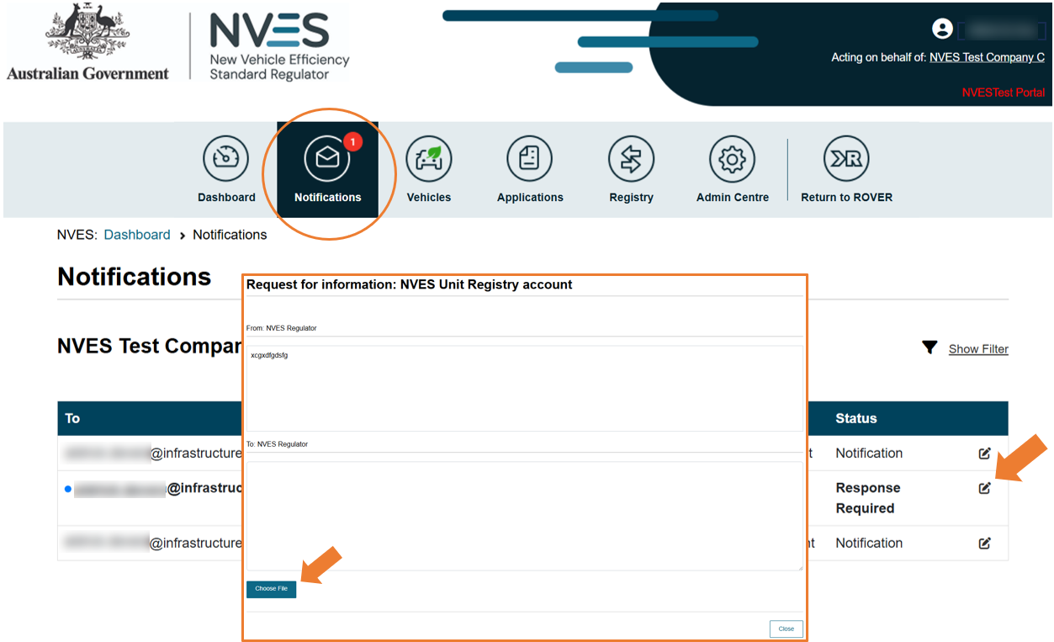

Vehicles
The Vehicles page can be accessed by clicking on the third icon in the portal’s banner. See screenshot below.
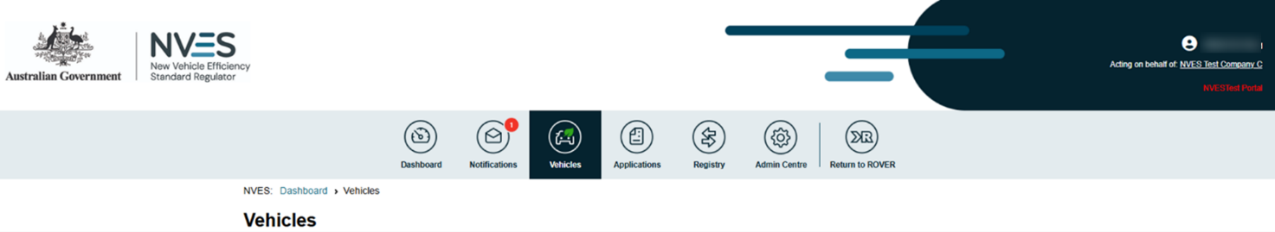
This page shows the NVES vehicles your entity has entered on the RAV. You can track and reconcile these vehicles here.
On this page and under the heading ‘NVES data from RAV entries’ you can:
- view information about each covered vehicle, such as:
  - NVES vehicle type
  - carbon dioxide (CO₂) emissions
  - mass in running order (MIRO)
  - the emissions target.
- sort and filter the vehicles shown in the table by:
  - date (most recent to least recent – this is the default setting)
  - Vehicle Identification Number (VIN)
  - RAV entry date (date range)
  - approval number
  - vehicle type
  - make
  - model.
To do this, click on ‘show filter’ above the table on the top right-hand side. You can then choose how to filter your search. See screenshot below.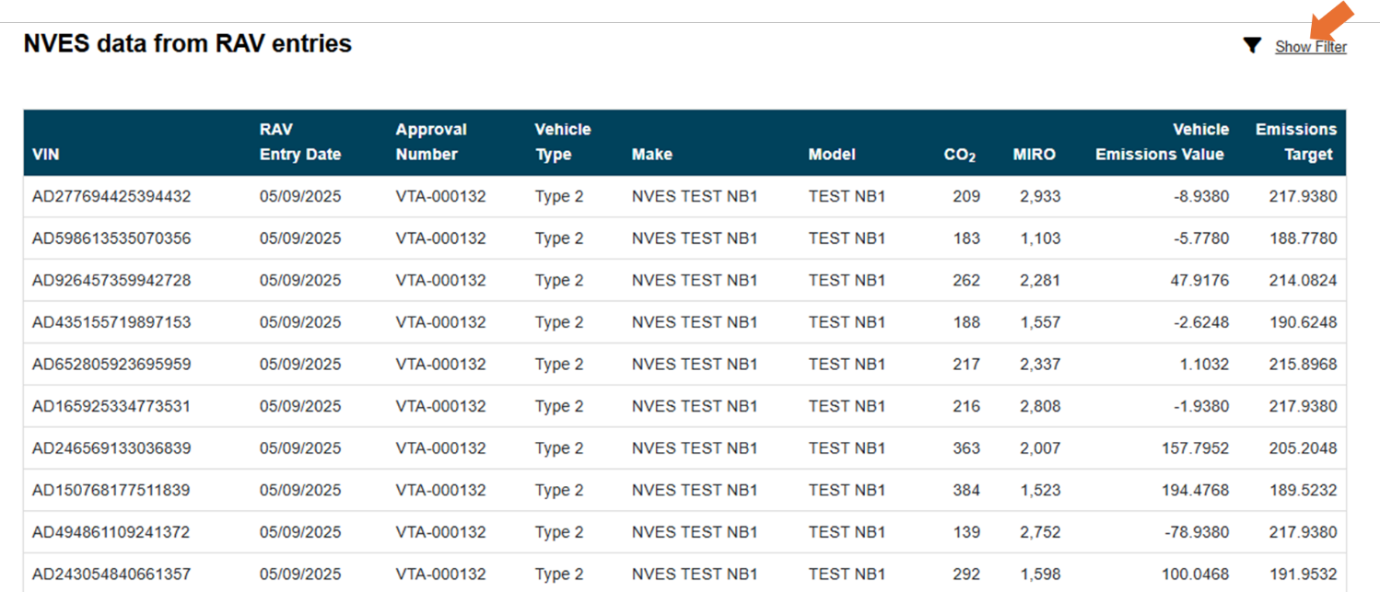
Once completed, you can export your data into an Excel file (up to 5,000 rows).
If you need to export more than the system limit of 5,000 rows, we recommend filtering your date range to smaller batches within the limit and conduct multiple exports. See screenshot below.
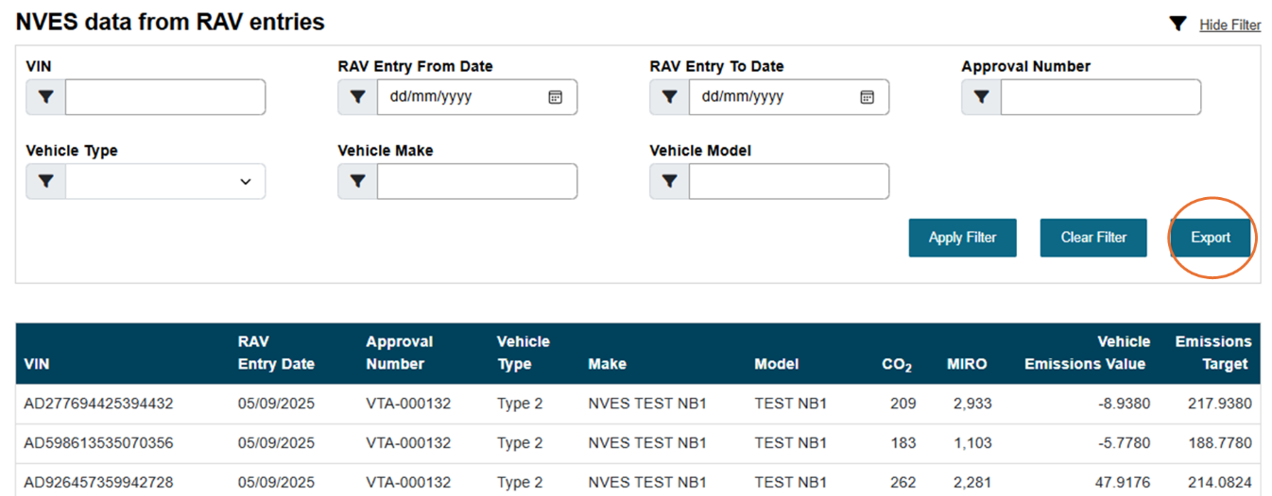

What is a vehicle type approval holder?
A vehicle type approval holder is the individual or company granted permission to provide a specific type of vehicle to the Australian market under a vehicle type approval as per the RVSA.
More information can be found in the department’s guide to vehicle type approvals.

Applications
The applications page can be accessed by clicking on the fourth icon from the left in the portal’s banner. See screenshot below.
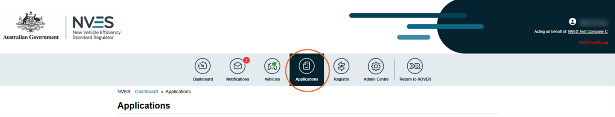
The applications page shows all NVES applications in one place. On this page you can apply for:
- a unit registry account
- non-standard issuance of units (RAV correction after the IEV was issued)
- non-standard issuance of units (vehicle destroyed after the IEV was issued).

Applying for a NVES Unit Registry Account
To apply for a unit registry account, navigate to the ‘Apply for an NVES Unit Registry Account’ tile. This will take you to the application page.
The application page has 4 sections you will need to complete:
- your organisation details including your executive officer
- your details, including your secondary contact (if applicable)
- an fit and proper (FPP) declaration about you and your organisation
- review your application and submit.
The screenshots on the next pages outlines this.
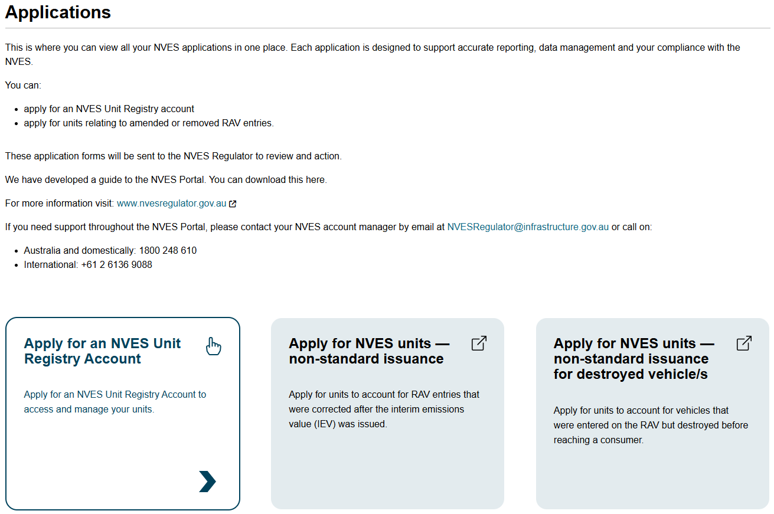
Before you begin the application
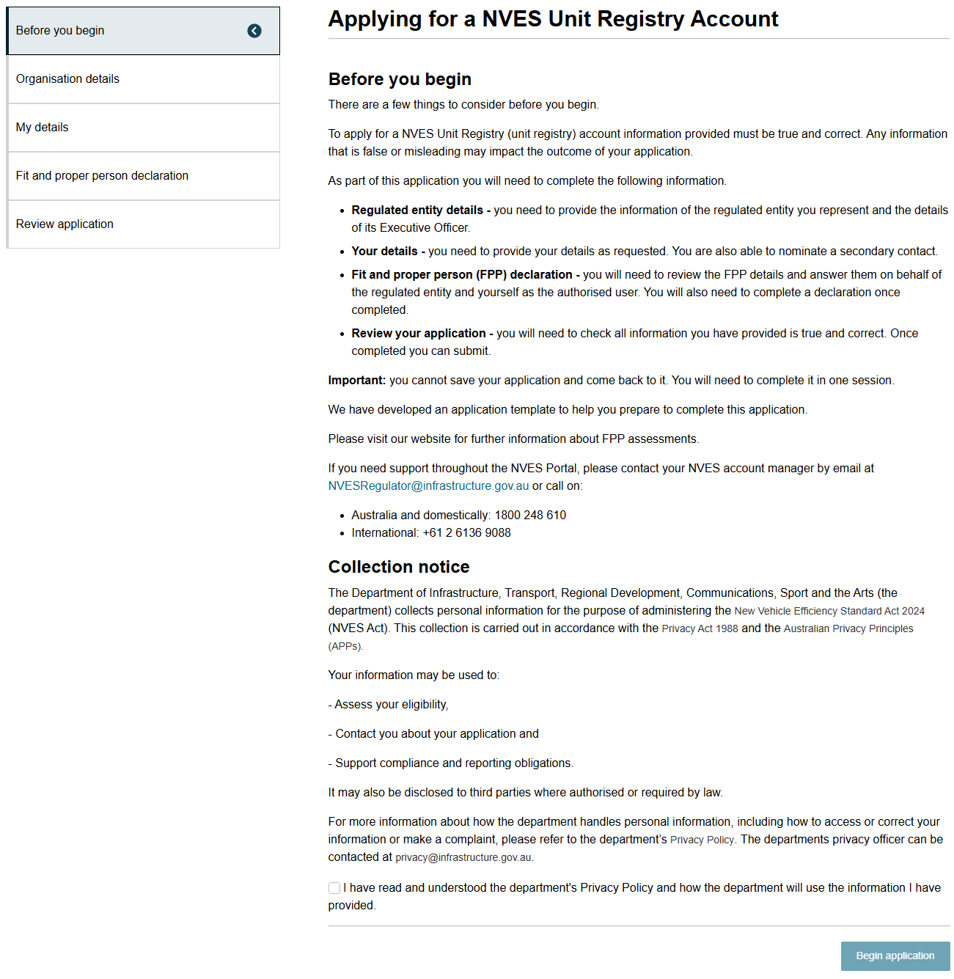
Organisation details
The details on this page will be pre-populated from the existing records. Any changes made to the Executive Officer details here will update our records.
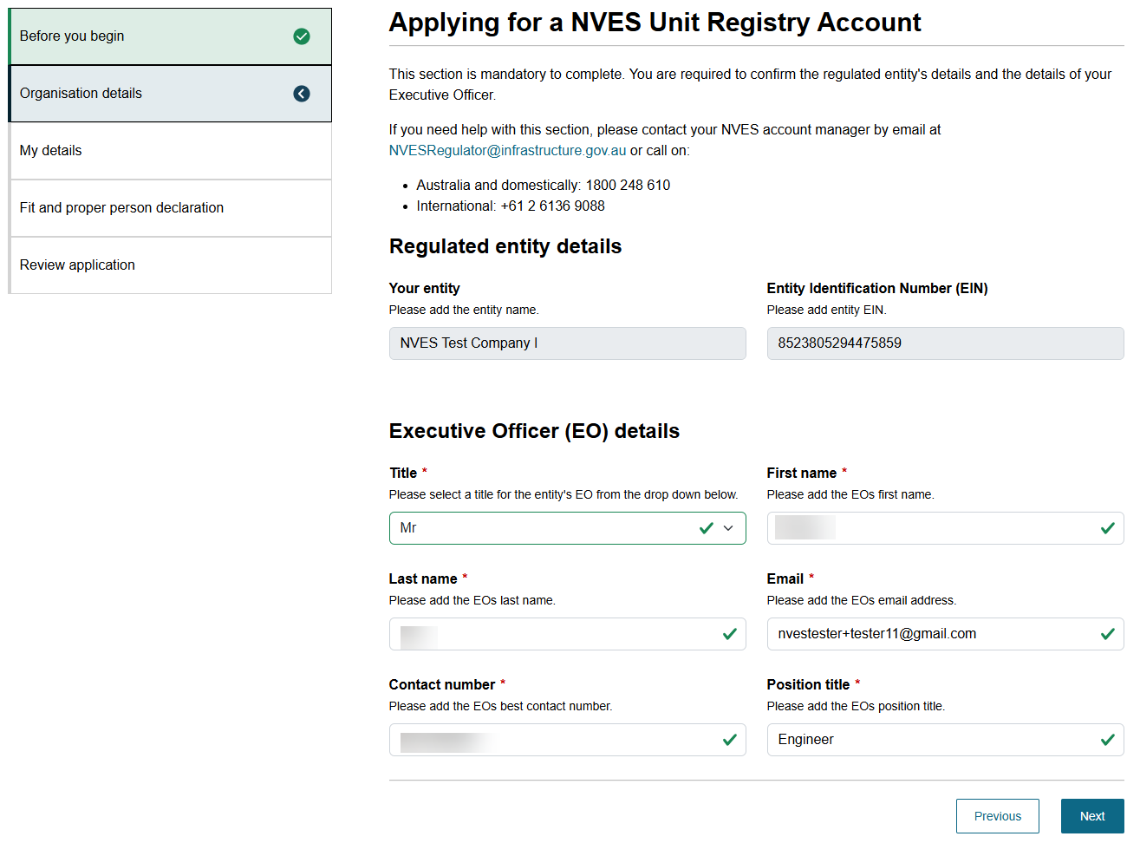
Applicant details
You need to provide your contact details. You may also include details for a secondary contact, if applicable.
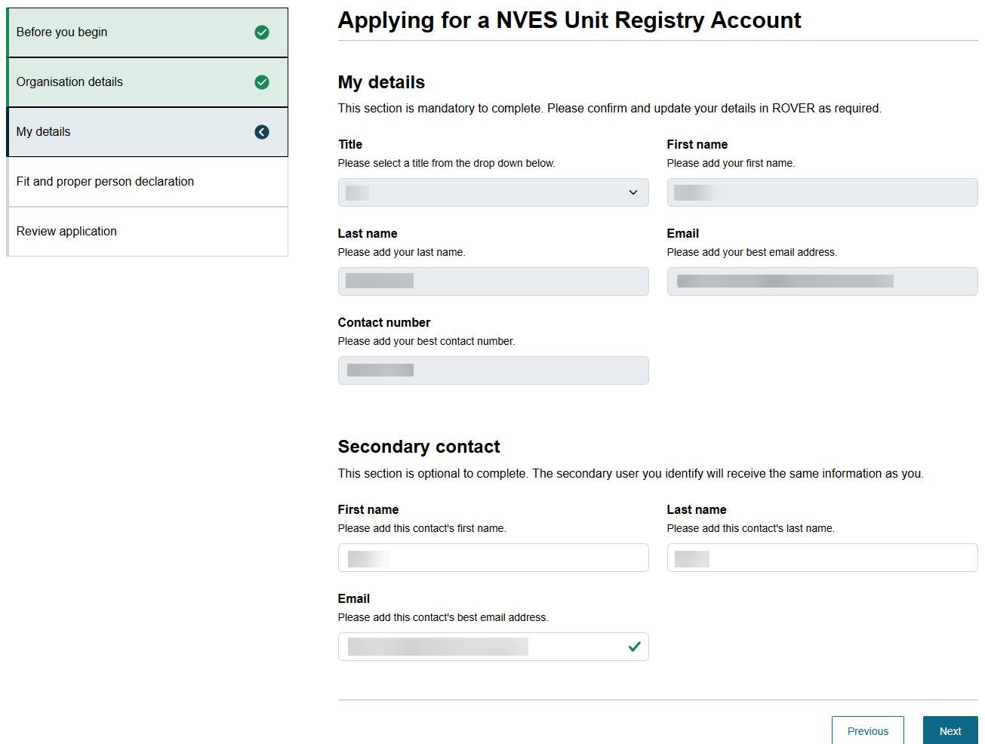
Fit and proper person declaration
To complete the page of the application, please refer to the fit and proper person guidance on the NVES Regulator’s website.
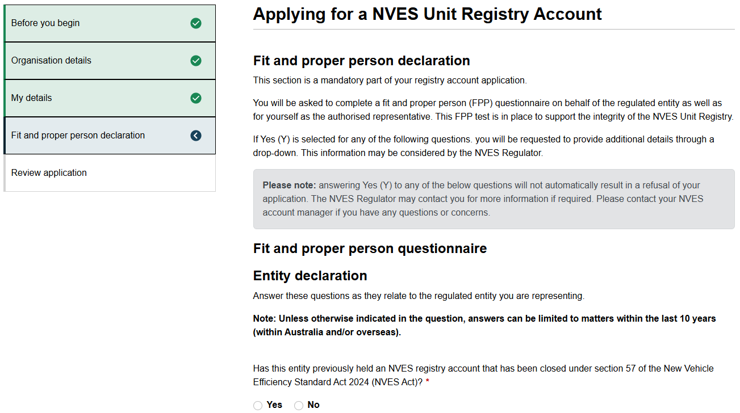
Review application
This page displays your completed application, including the ‘Entity declaration’, ‘Individual declaration’ and an application ‘Declaration’. The screenshot below is for illustrative purposes only and does not show completed application details.
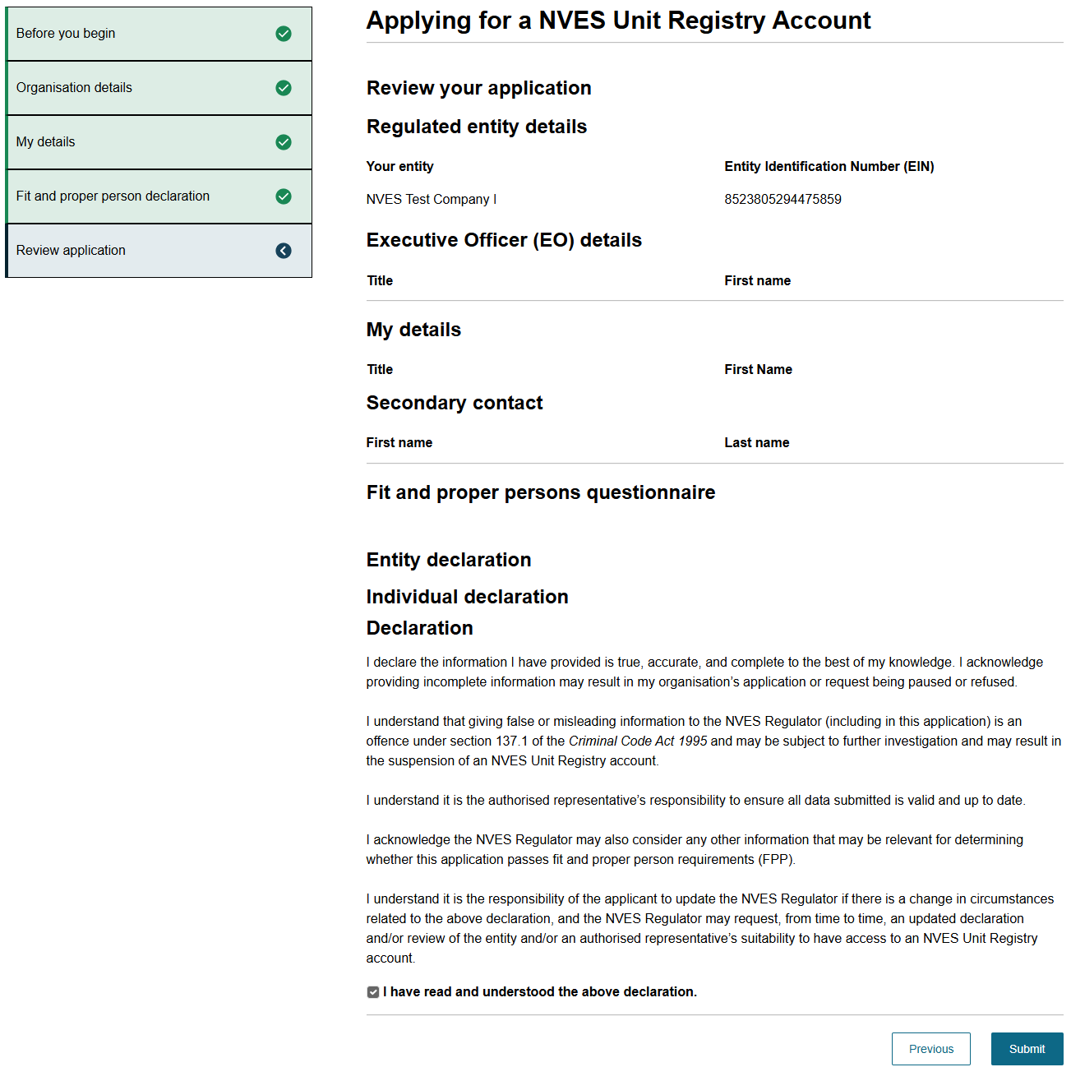
Important: You can only apply for a unit registry account once.
Applying for a unit registry account can only be completed by one user for each entity.

Applying for non-standard issuance of units
What do we mean by non-standard unit issuance?
Non-standard unit issuance is an application where an entity can apply for units to be issued to them because of a destroyed vehicle or due to a vehicle correction after the IEV for the performance year has been issued.
Note: You must have a unit registry account to receive NVES units.
You can apply for non-standard issuance of units (additional units) following accepted and successful completion of a RAV adjustment or destroyed vehicle after you have received your IEV for a performance year.
A RAV adjustment is determined after a RAV correction has been applied for and accepted. Further information about the RAV corrections process is here.
Note: this application can only be used in limited circumstances (see eligibility criteria below). It is not related to the standard issuance of NVES units that occurs in February 2026 of each year once an entity beats the emissions target and receives an IEV below zero.

Non-standard issuance: RAV adjustment
You can only make this application if you meet all the following criteria:
- your organisation has an active unit registry account
- your organisation has made corrections to the NVES covered vehicles that were first entered on the RAV in a previous performance year(and they have been approved on the RAV with evidence)
- these corrections occurred after your organisation's IEV for that year was issued
- the corrections would have affected your organisation's NVES performance if they had been made before the IEV was released.

Non-standard issuance: destroyed vehicles
You can only make this application if you meet all the following criteria:
- your organisation has an active unit registry account
- your organisation has NVES covered vehicles that were entered on the RAV in a previous performance year, but were destroyed and never provided to a consumer for the first time in Australia.
See screenshot below.
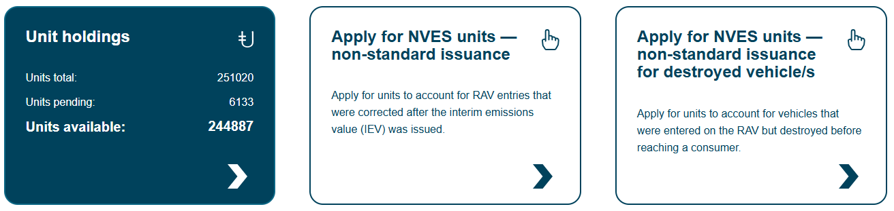

How to apply
To apply for this, you will need to login to the portal.
You can use this template bulk upload for non-standard unit issuance application template [Excel 11.11 KB] to upload a bulk non-standard unit issuance application in the portal.
If you have any issues or questions about this template, please contact your NVES Account Manager via email at NVESRegulator@infrastructure.gov.au.
Step 1: Login to the portal and navigate to the ‘Registry’ page
- In the NVES Portal, select one of the following tiles:
- Apply for NVES units — non-standard issuance
- Apply for NVES units — non-standard issuance for destroyed vehicle/s.
- You will be taken to the relevant non-standard unit issuance application page. Both application pages have 2 sections you will need to complete, they are:
- Application detail – this includes:
  - the number of units you are applying for
  - list of relevant VINs
  - the performance year when they were entered onto the RAV.
- Review application details and final submission – this is where you can provide a list of VINs manually or as a bulk upload.
An example of the bulk upload CSV file is shown below.
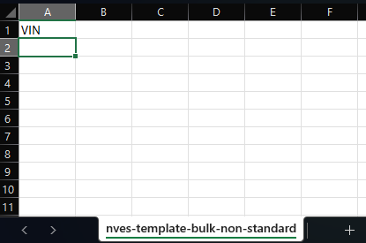

Using the CSV template
Step 2: Download the template
- On the application page, locate the question “Provide a list of relevant VINs that are the basis of this application for units.”
- Select the link titled ‘bulk upload for non-standard unit issuance application’ (CSV), it will send you to this page of our website.
- Download the file and save it to your computer. You will note the file is an excel XSLX file and not a CSV.
Step 3: Complete the CSV file
- Open the downloaded XSLX file using a compatible program (for example, Microsoft Excel).
- Under the VIN column:
- Starting from cell A2, list one VIN per row.
- Only include VINs that meet the criteria for the application.
- Do not change the text in cell A1.
- If the text in A1 is altered, the file will fail validation and cannot be uploaded.
Step 4: Save the completed file
- When all VINs have been entered, save the file as a CSV:
- File format must be CSV (.csv).
    - To do this go to File > Open and select the XLSX file you want to convert. With the file open, go to File > Save As. Choose a location on your computer where you want to save the CSV file. In the Save As drop-down menu, select CSV (Comma delimited).
- Use a clear file name (for example, Non-standard units bulk upload - Bottle Brush Motors - April 2026.csv).
- Confirm the file size is not larger than 1MB.

Step 5: Upload the file to the portal
- Return to the NVES Portal application page.
- Select the ‘File upload’ option.
- Select ‘Choose files’.
- Select your completed CSV file and upload it.
Note:
- Only one file can be uploaded per application.
- The maximum allowable file size is 1MB.
You will be notified once the regulator has made a decision about your application. This will be displayed under the ‘Notifications’ page in the portal.
If the decision results in additional units being issued, the units will be deposited into your unit registry account within 24 hours, and your entity’s unit holdings will be updated accordingly.

Registry
The registry page can be accessed by clicking on the fifth icon from the left in the portal’s banner. See the screenshot below.
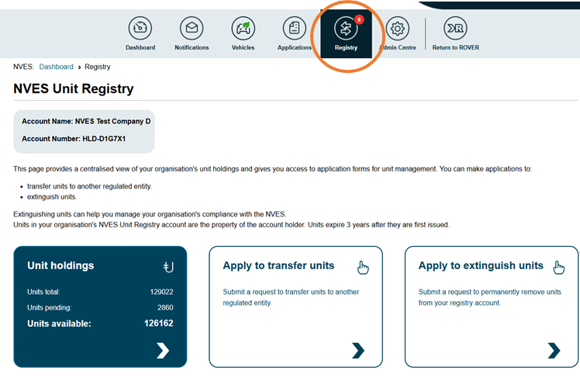
On the registry page, you can:
- check the unit holdings of your entity, including any units pending and available units
- apply to transfer or extinguish units if you have the appropriate role (such as ‘Initiator’)
- see recent and pending transactions for your entity and its emissions performance.

Unit holdings
To access more information about units, navigate to the ‘Unit holdings’ tile on the ‘Registry’ page.
See screenshot below.
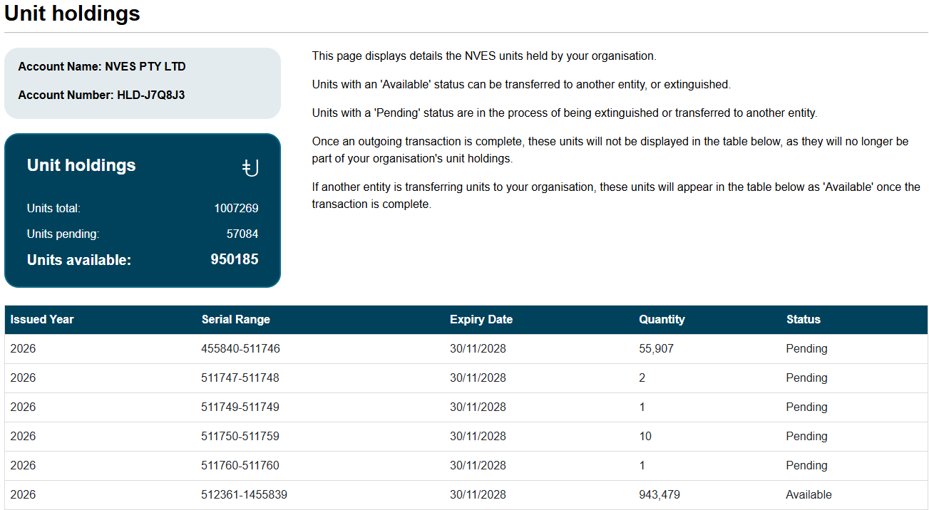

Pending transactions table
On the ‘Registry page’ you will see a ‘Pending Transactions’ table (an example screenshot is below). It lists transactions that have been initiated and are awaiting authorisation by a user in your organisation.
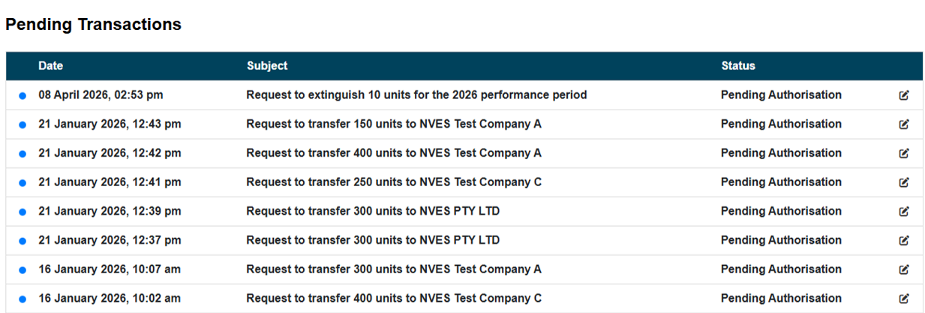

Emissions performance table
Further down on the ‘Registry’ page you will see an emissions performance table. An example screenshot is below.
It displays information about your organisation’s compliance status for each performance year. It includes:
- performance year
- interim emissions value (IEV)
- (units) pending extinguishment
- extinguished units
- current balance
- performance year status
- final reconciliation date
- action.
Performance year status symbols
If your emissions performance for a set year exceeds the emissions target you will see a red triangle with an exclamation mark and the action you will need to take by the final reconciliation date.
If your emissions performance is on track you will see a tick in a green circle.
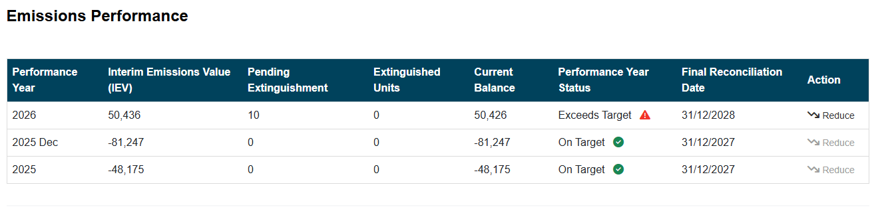

Apply to transfer units
To apply to transfer units, you will need to navigate to the ‘Apply to transfer units’ tile on the ‘Registry’ page. This will take you to the application page.
The application page has 4 sections you will need to review and complete:
- Before you begin with important information about initiating a transfer.
- Recipient details to provide important details about the entity receiving the units.
- Select units which allows you to select the units you would like to transfer.
- Review your application and submit.
Only users with an ‘Initiator’ permission for an entity can apply to transfer units.
You can find a screenshot of each of the 4 sections on the following pages.

Before you begin
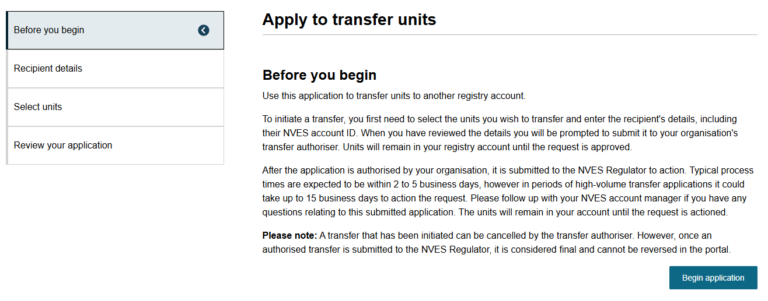
Recipient details
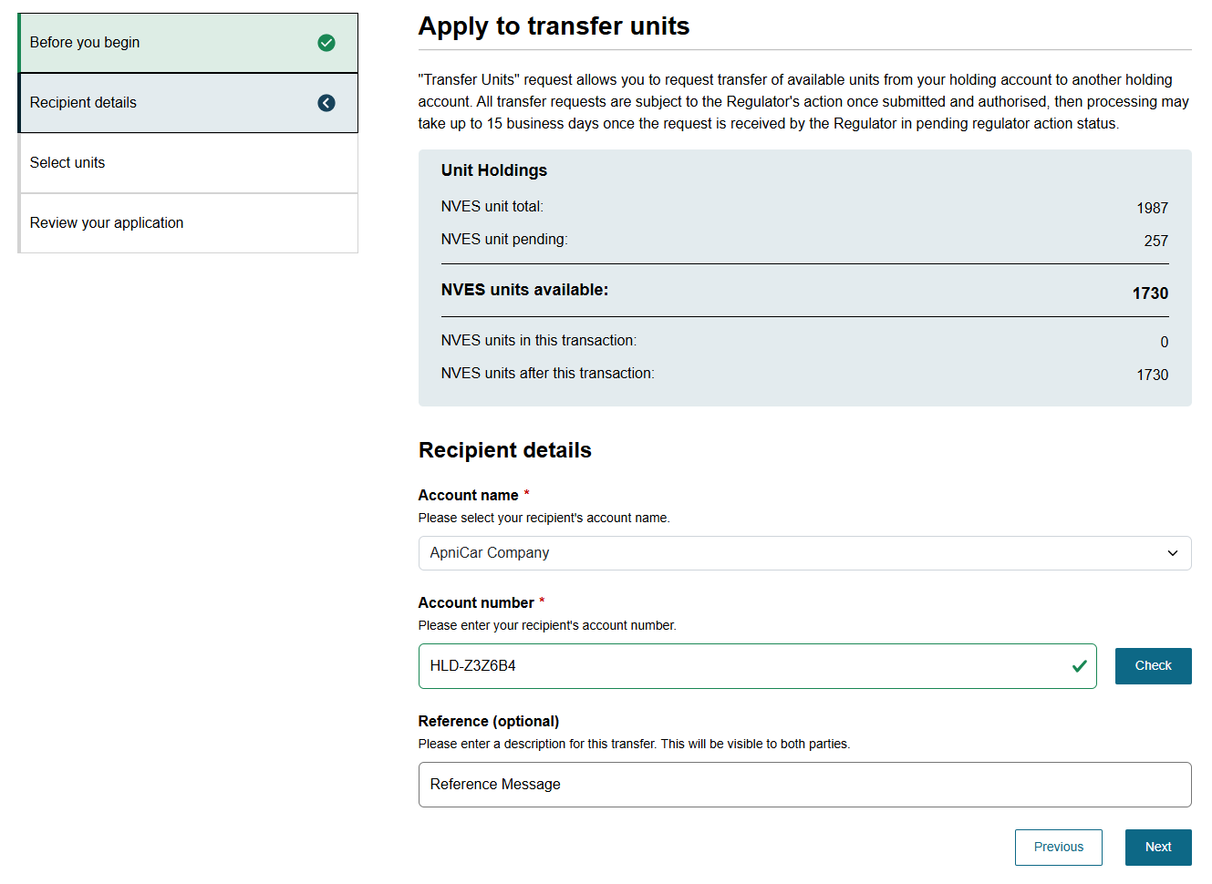

Select units
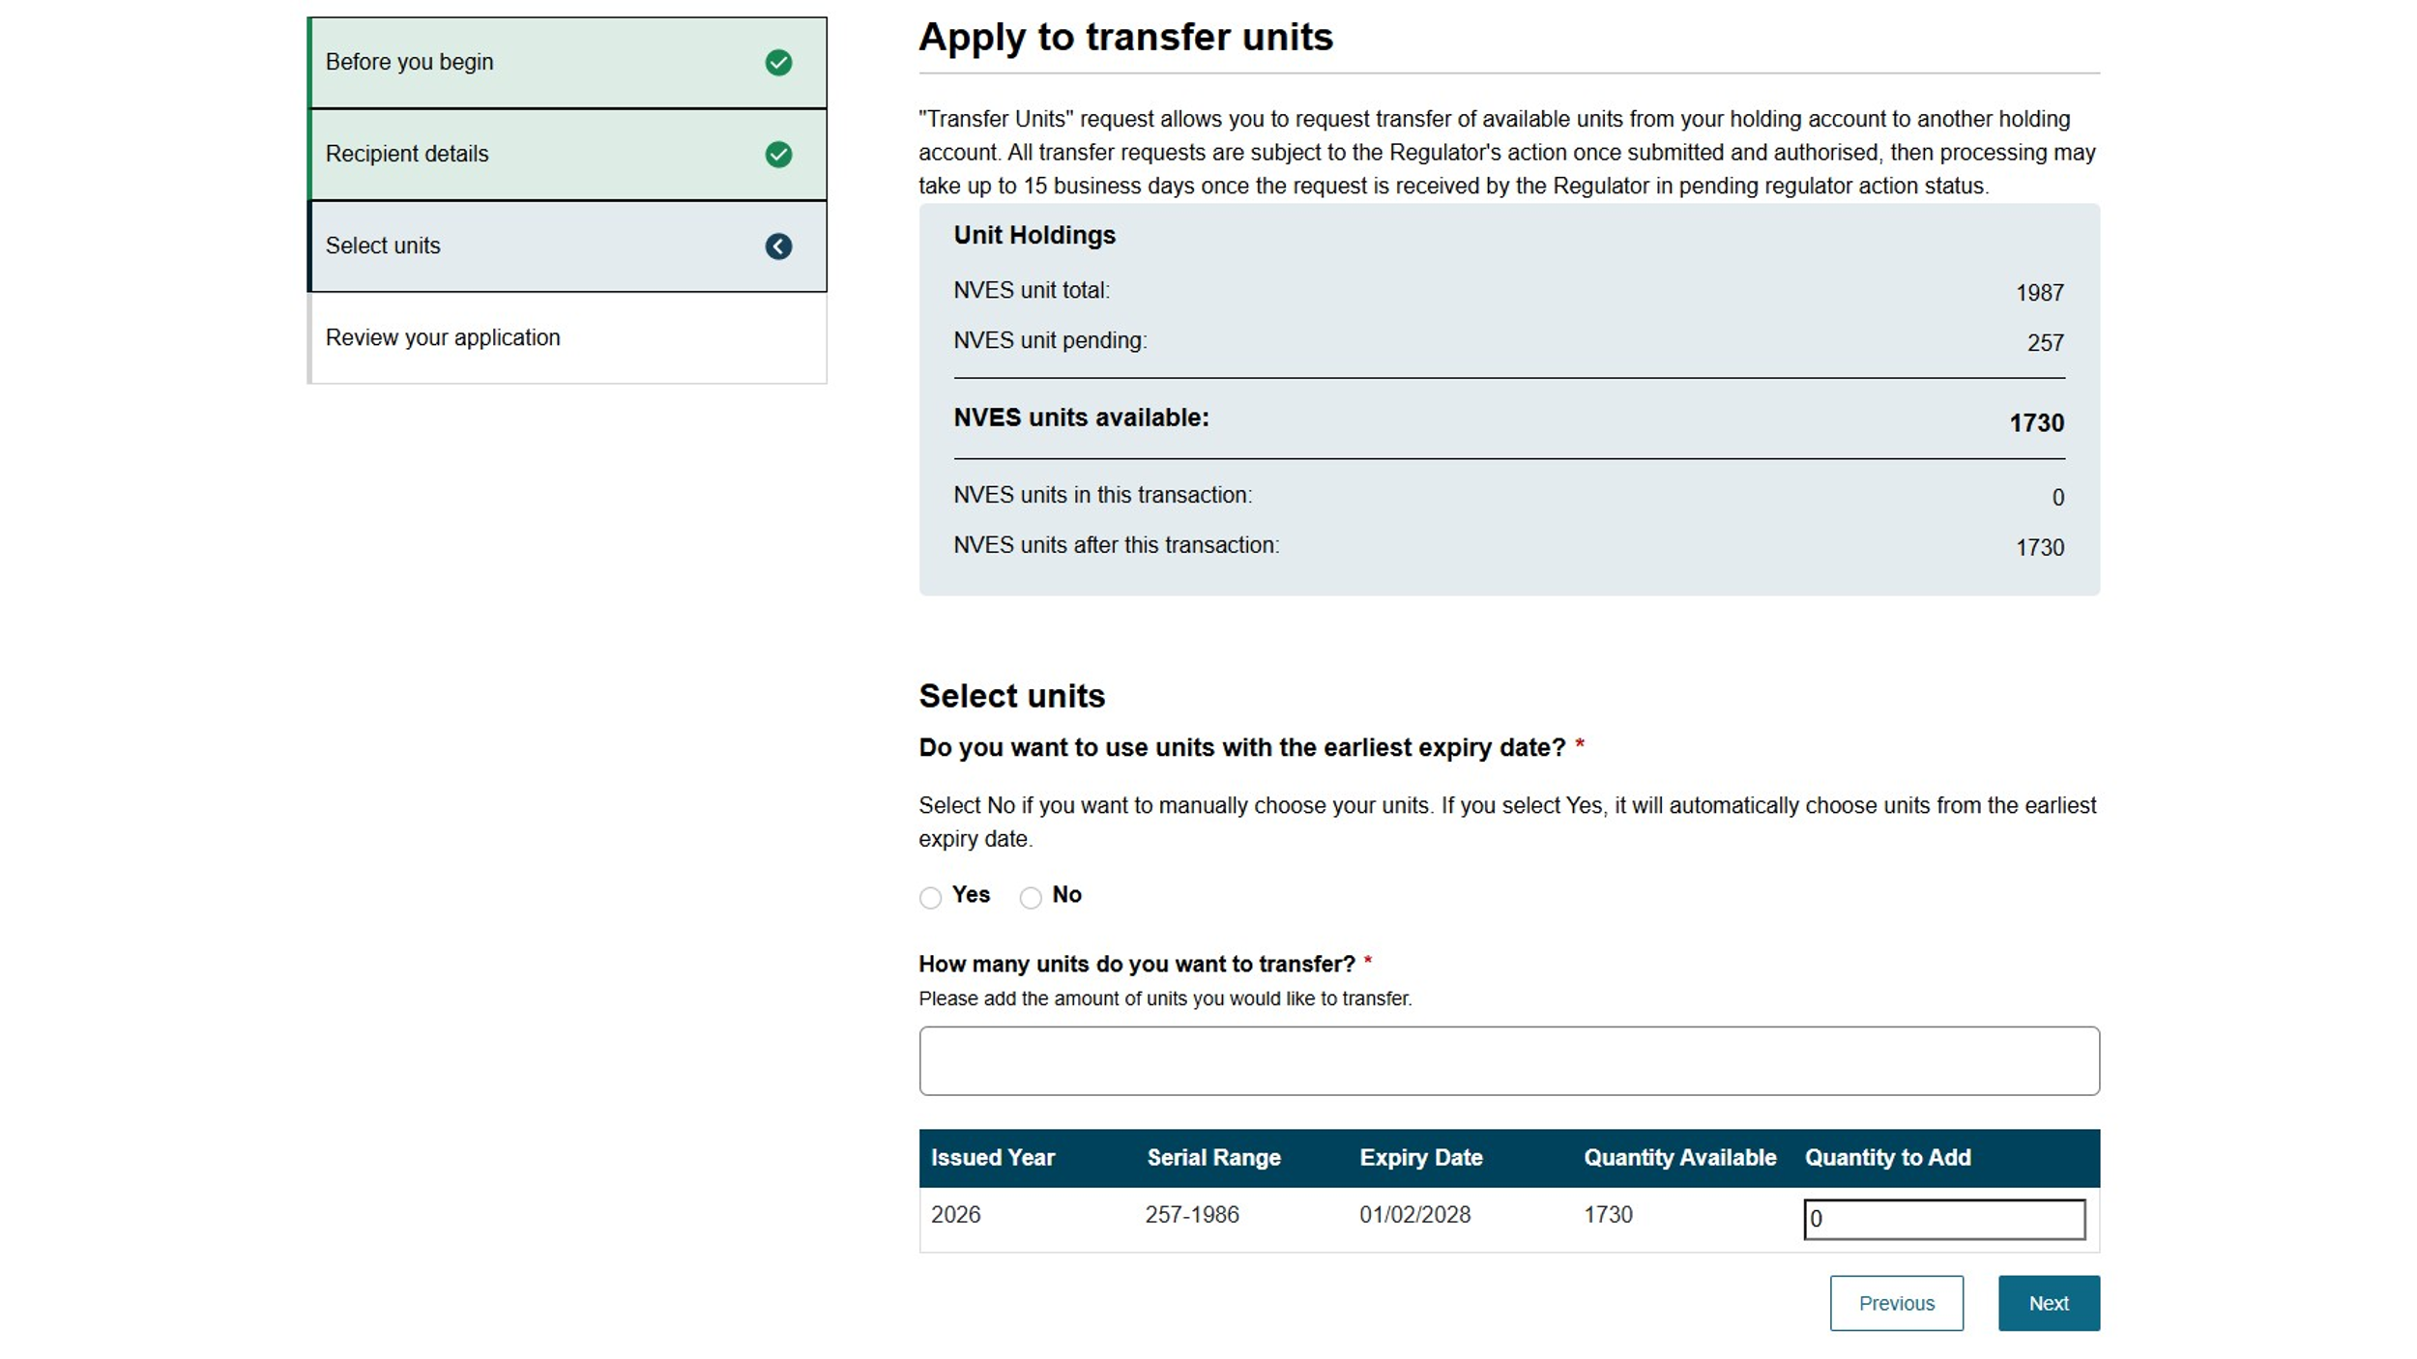
Review your application
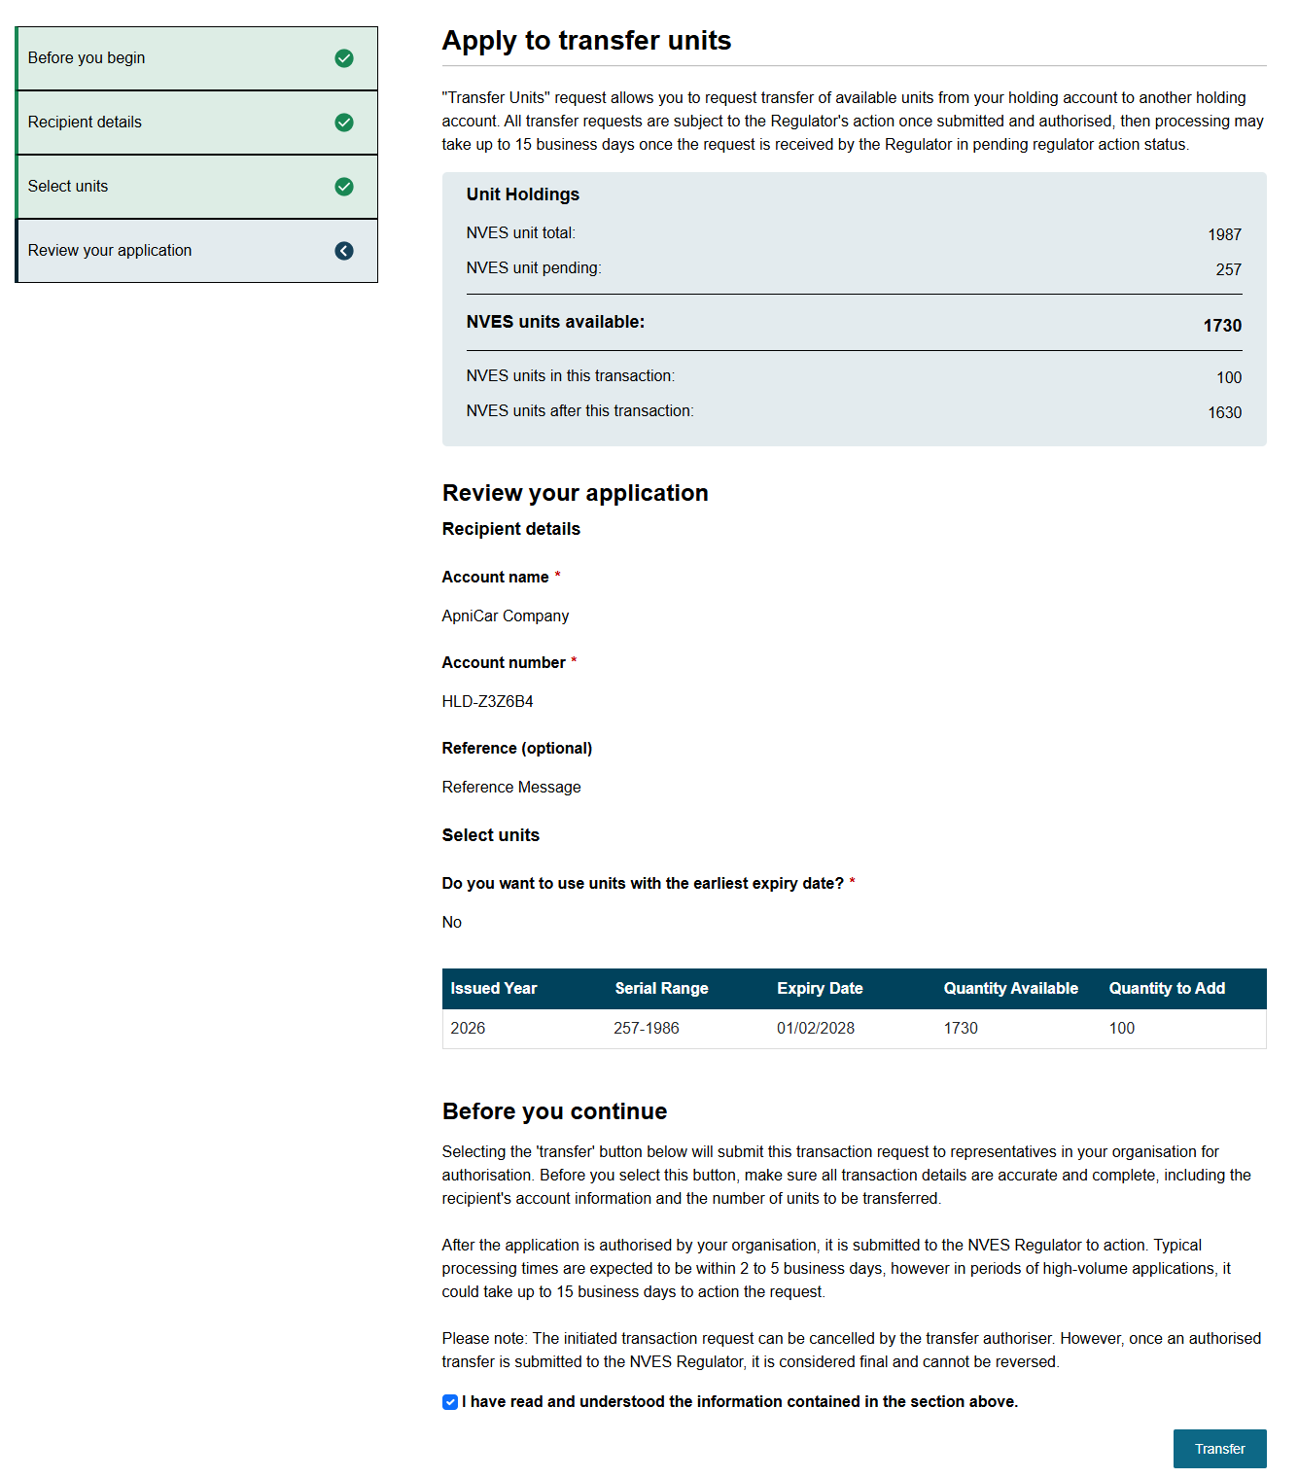
Post application submission
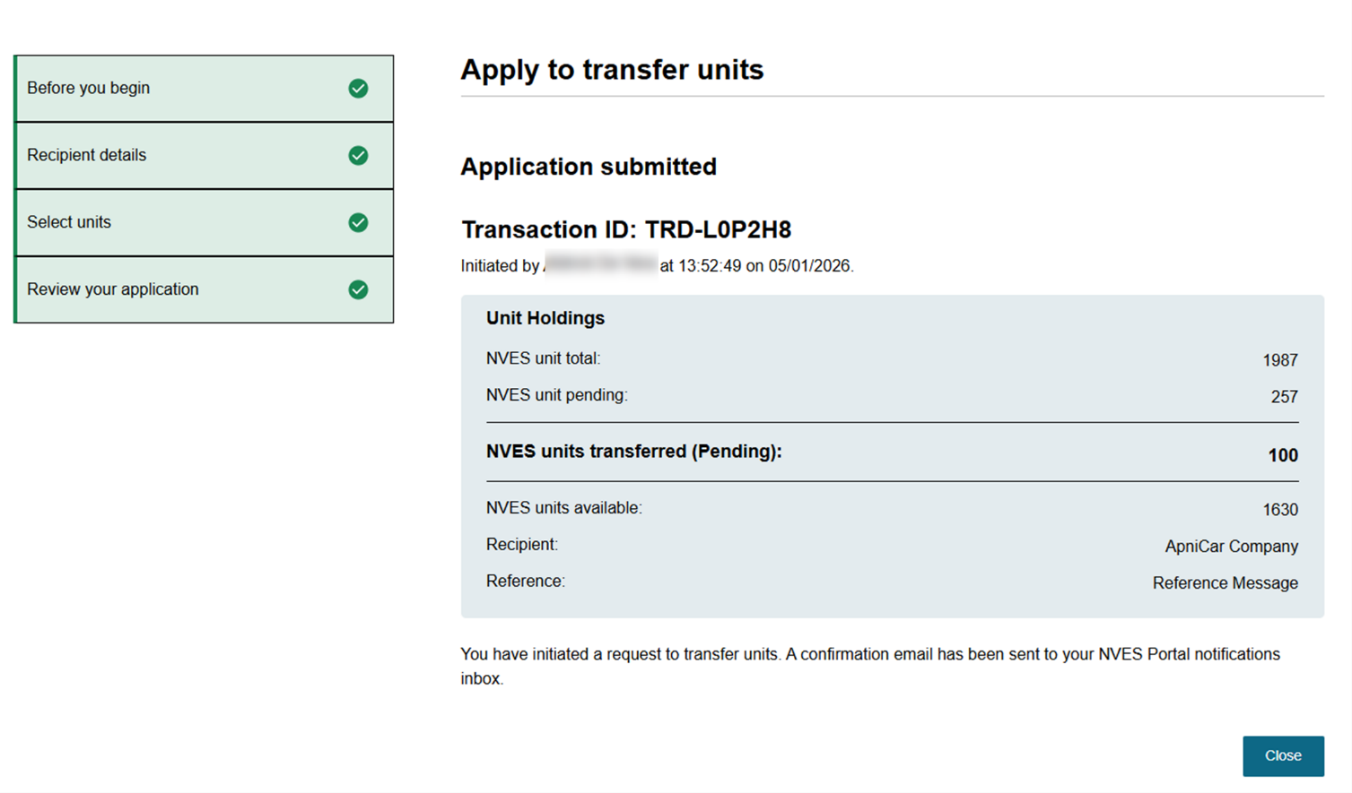

Authorising the transfer of units
Only users with an ‘Authoriser’ permission for an entity can authorise a unit transaction initiated by an ‘Initiator’ in the same entity. They cannot be initiated and authorised by the same user.
To open a pending authorisation application, navigate to it under recent transactions on the ‘Registry’ page. See screenshot below.
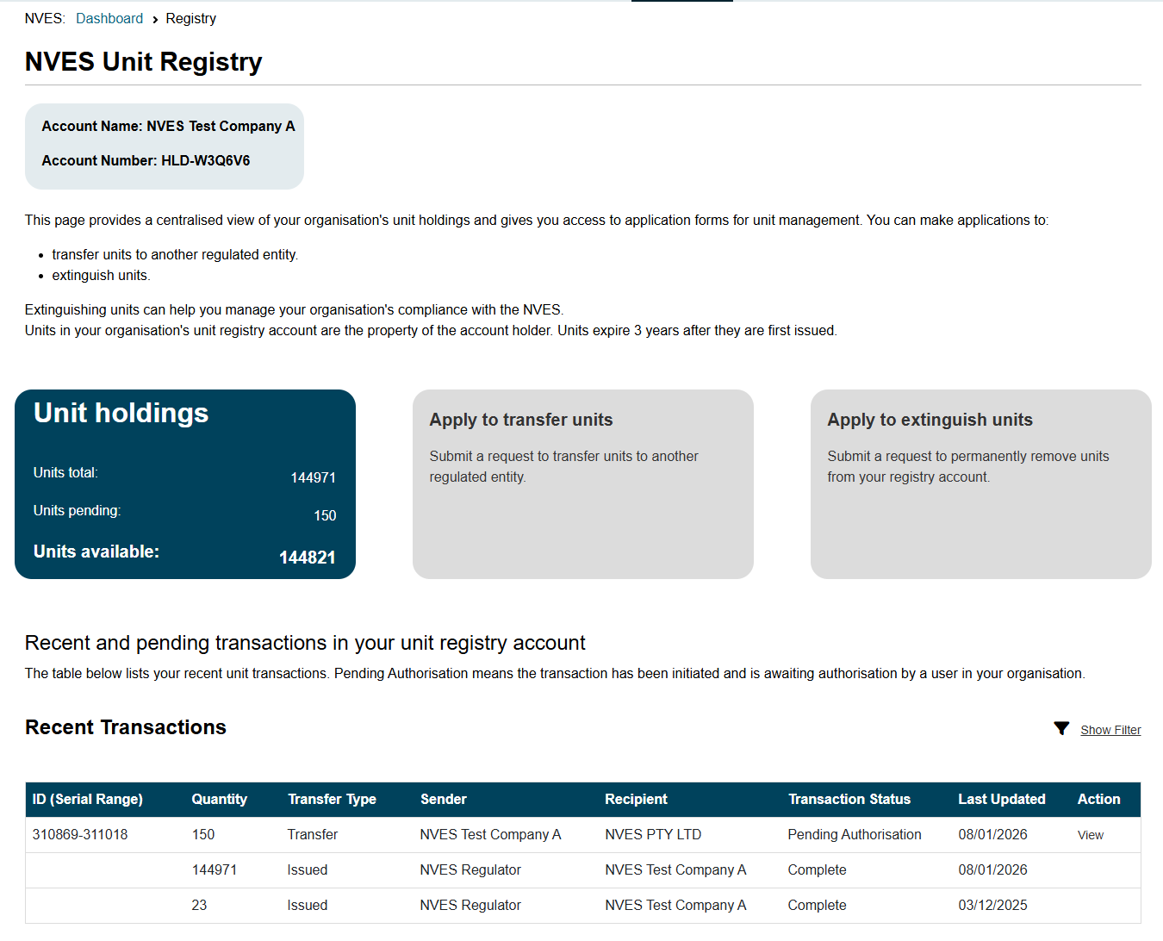
After checking the transaction details, you can either authorise or deny the transfer request. See screenshot below.
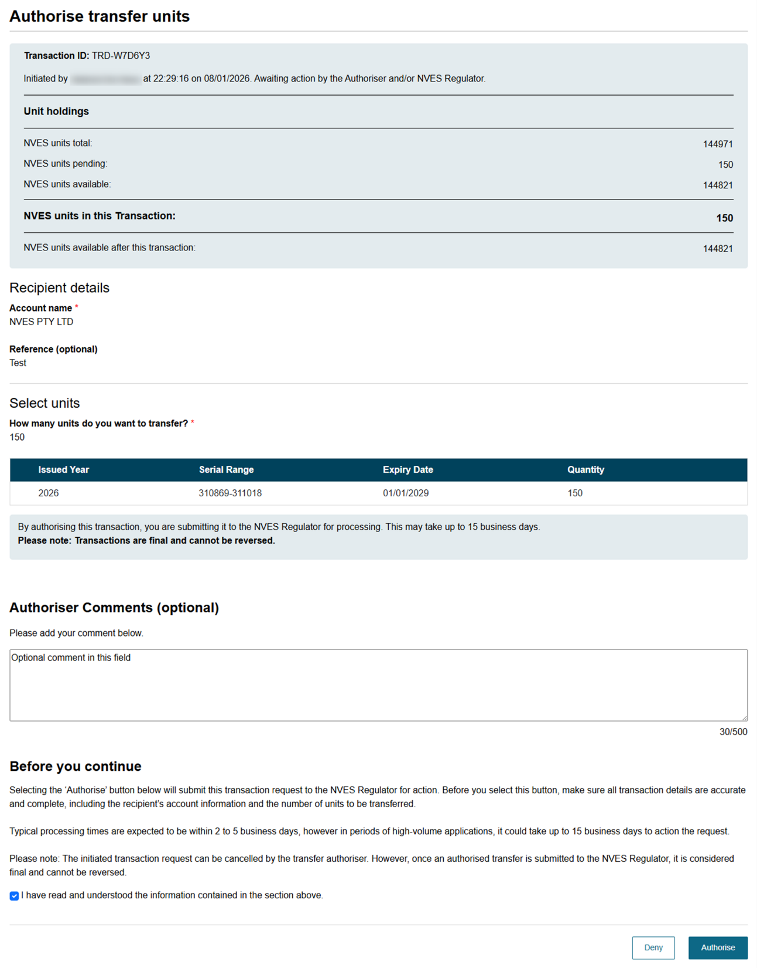
Once authorised, the transaction request will be sent to the regulator for action.

Apply to extinguish units
To apply to extinguish units, navigate to the ‘Apply to extinguish units’ tile on the ‘Registry’ page. This will take you to the application page.
The application process is similar to the ‘Apply to Transfer Units’ process. The application has 4 sections for you to review and complete:
- Before you begin section with important information on how to initiate an extinguishment of units.
- Extinguishment details section where you can see your available units and for what year you would like to extinguish them against.
- Select units section allows you to select the units you would like to extinguish.
- Review your application and submit.
We have provided screenshots of each of the 4 sections below.
Before you begin
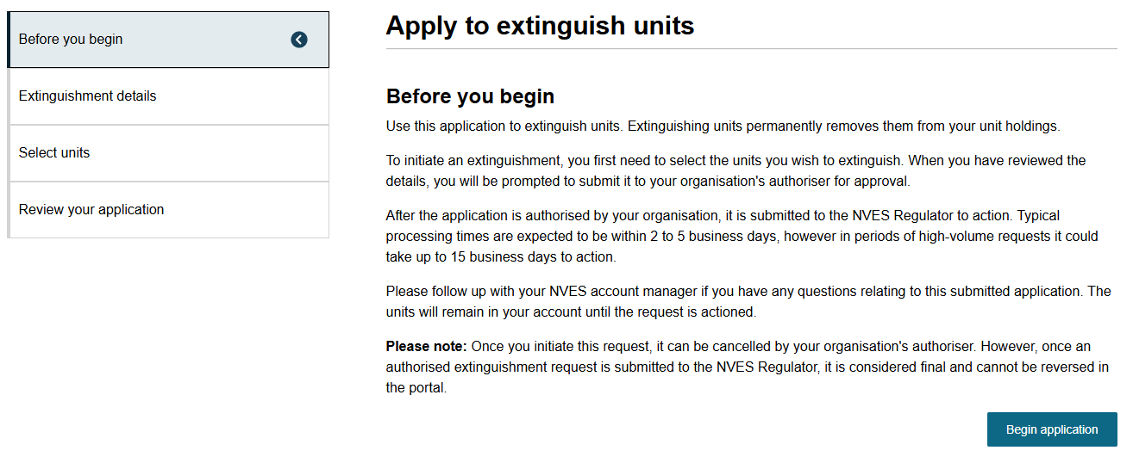

Extinguishment details
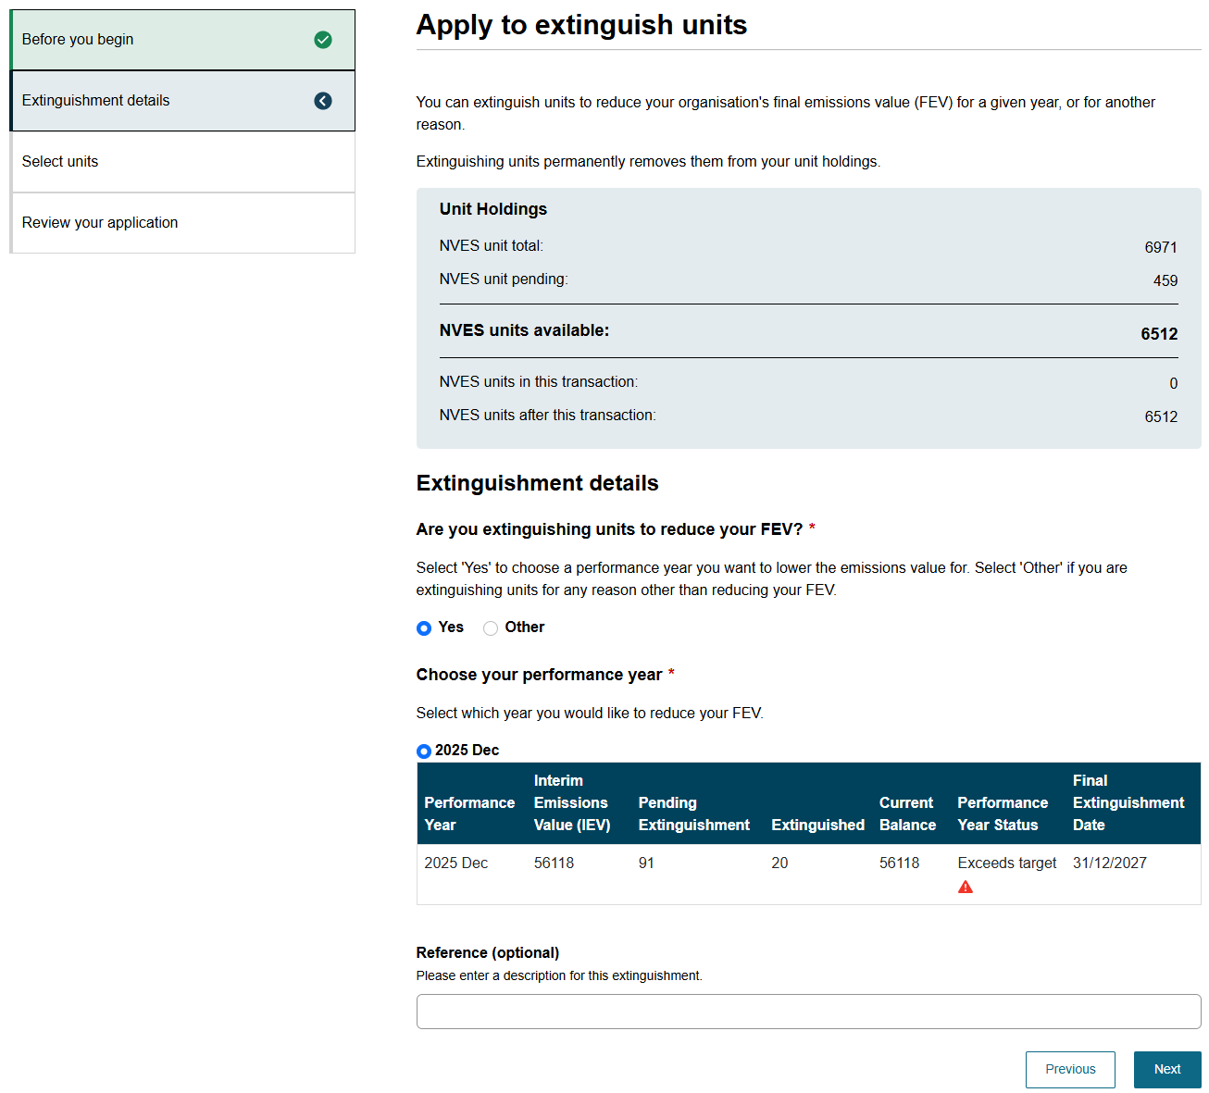

Select units
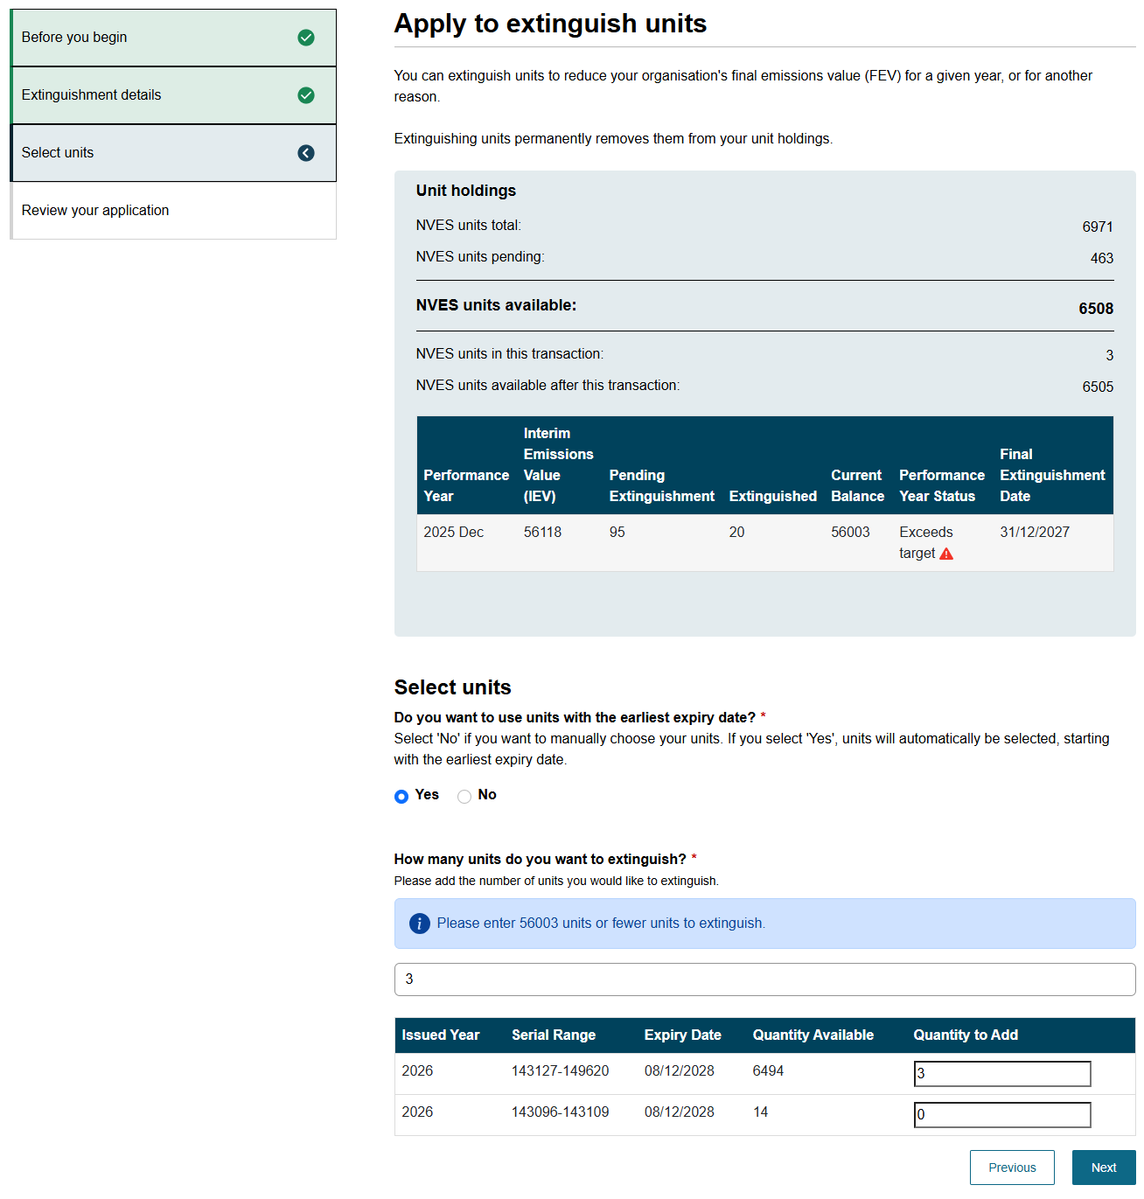

Review your application
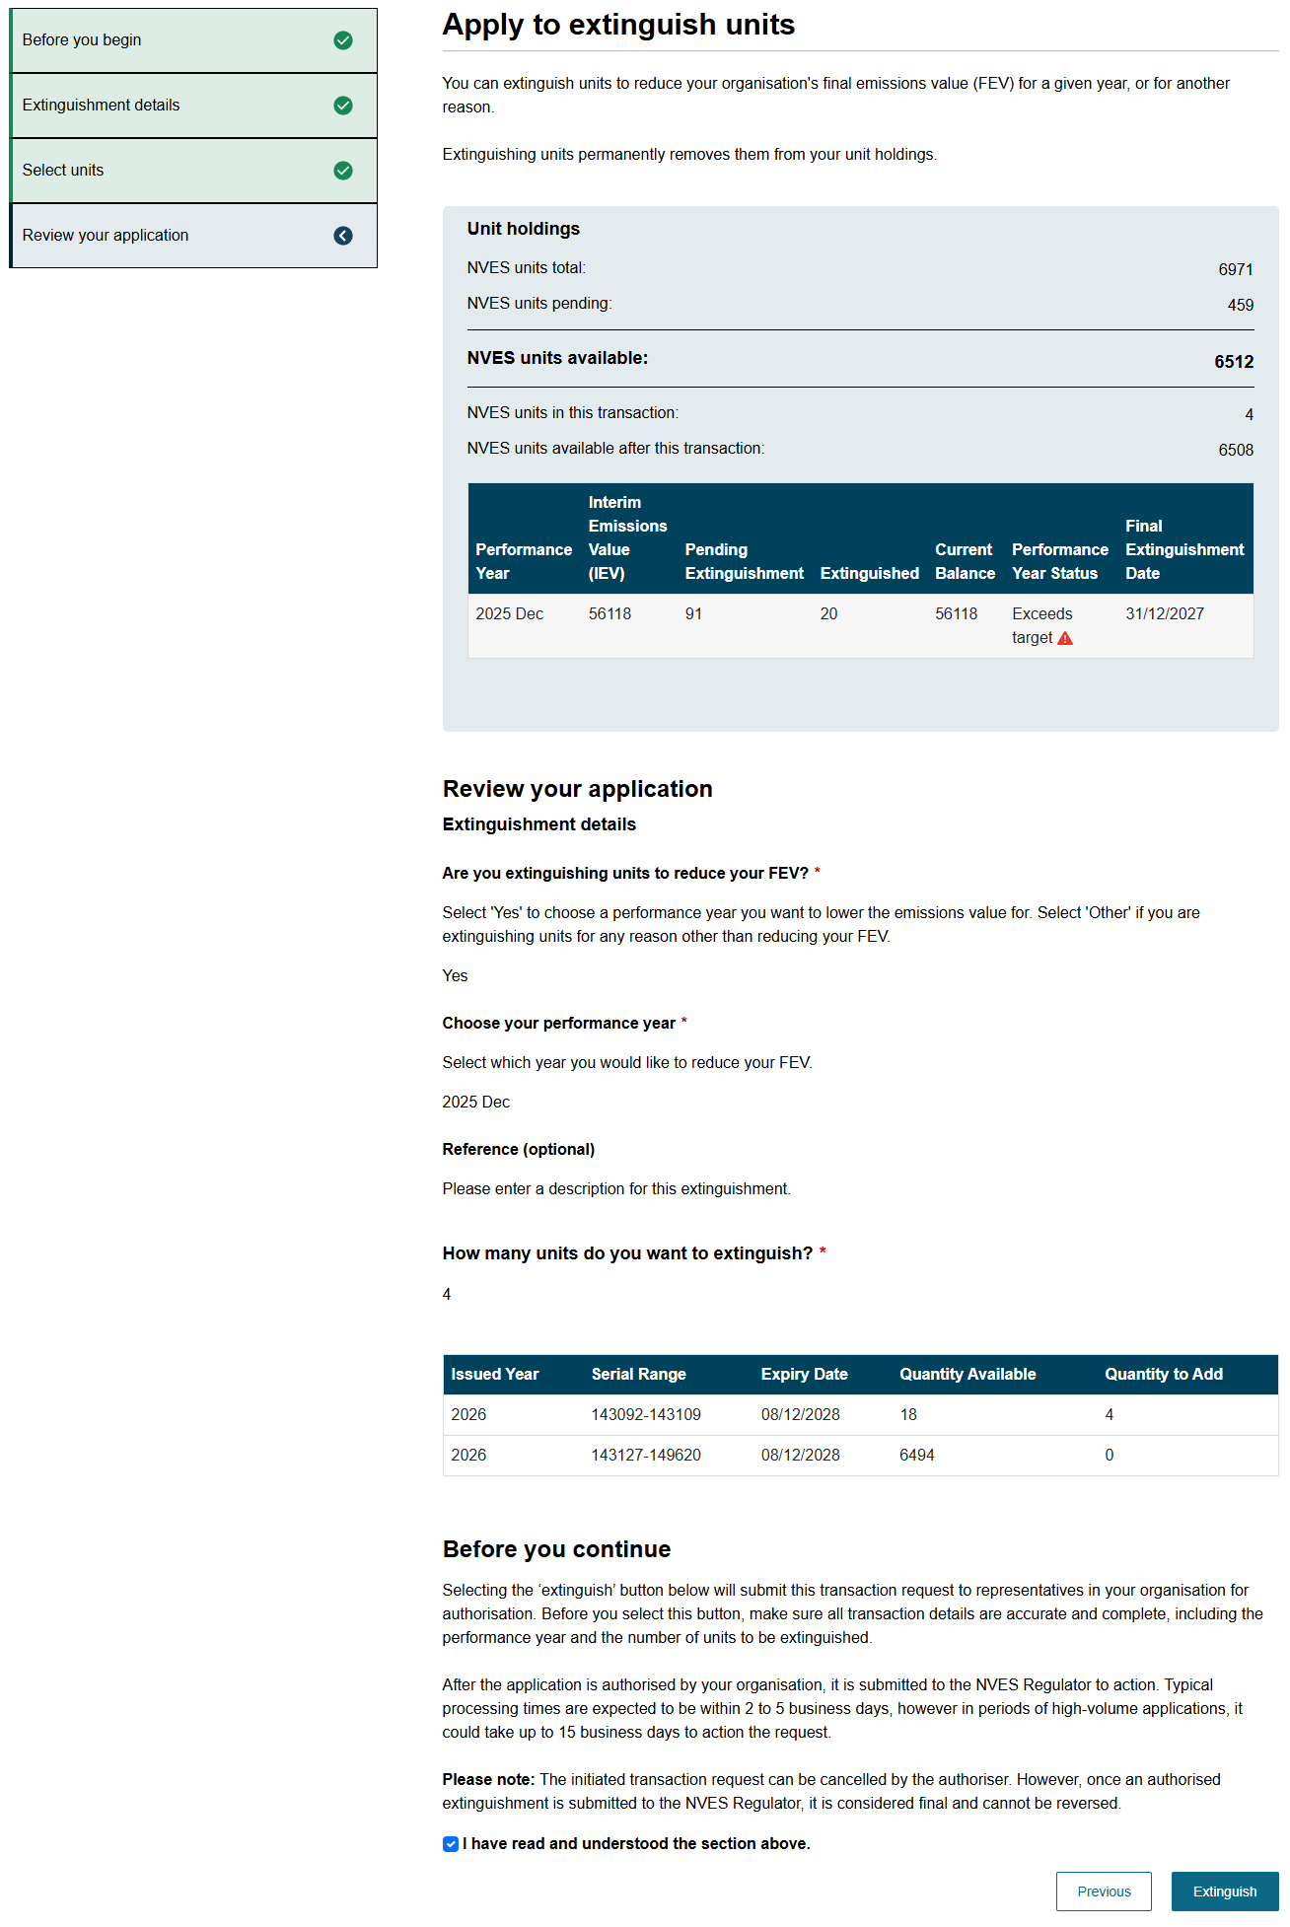

Post application submission
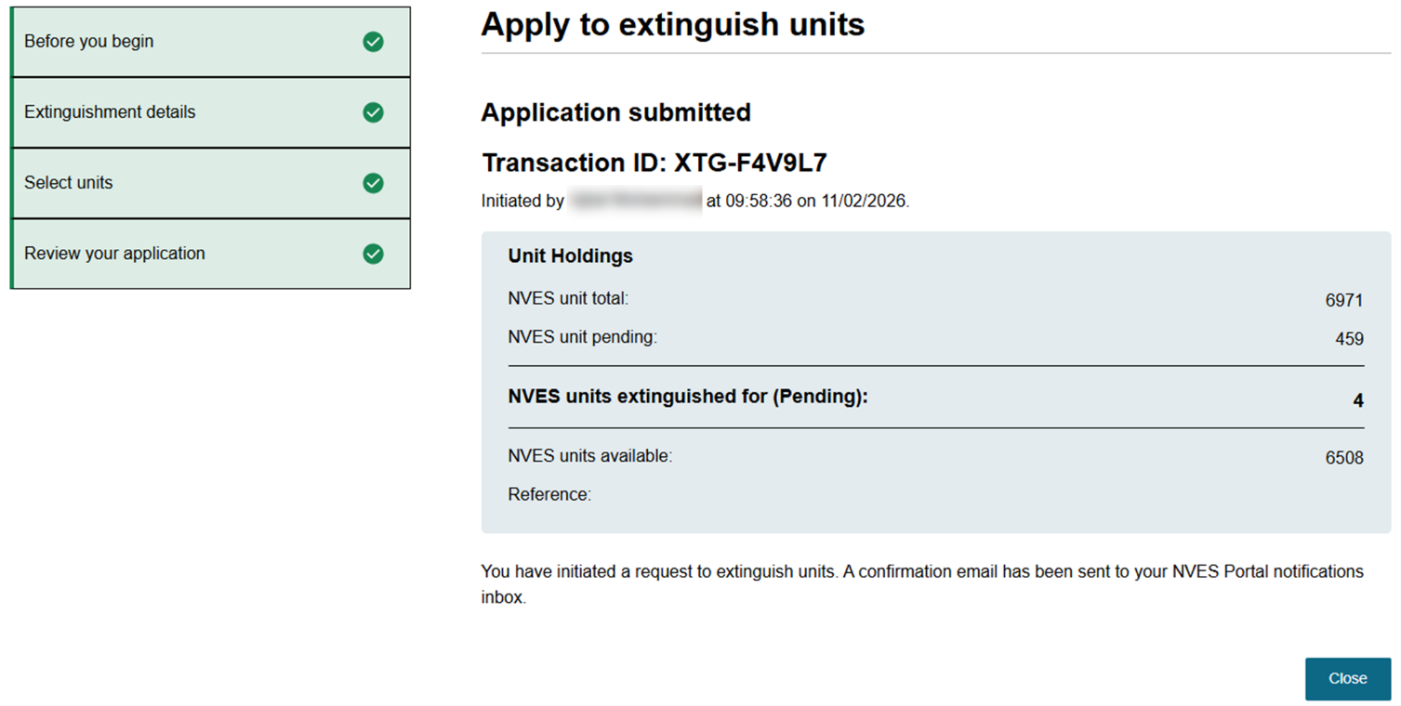

Authorise extinguishment of units
Only users with an ‘Authoriser’ permission for a regulated entity can authorise a unit extinguishment initiated by an ‘Initiator’. They cannot be initiated and authorised by the same user.
To open a pending authorisation application, you will need to navigate to the title ‘recent transactions’ on the ‘Registry’ page and view the transaction to be authorised. See screenshot below.
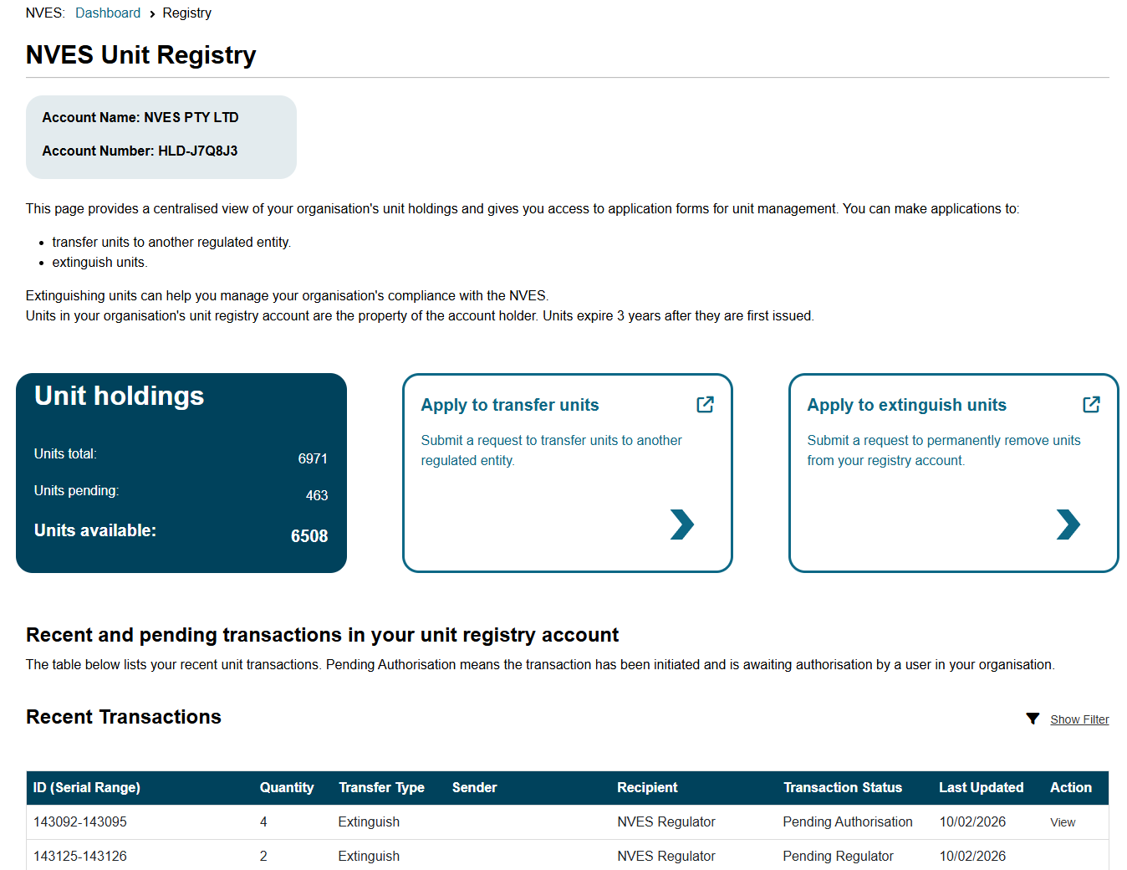

From there a user with an ‘Authoriser’ permission can review the application and authorise the trade.
The below screenshot outlines this.
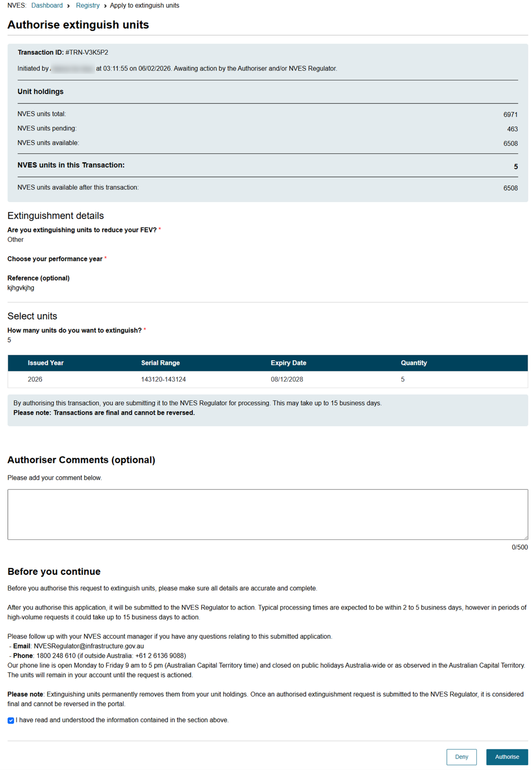
Important: Pending transactions authorisation risk
Pending transactions will fail if the ‘Initiator’ or ‘Authoriser’ permissions are revoked while the transaction is still in progress.
If an initiated transaction is still with an ‘Authoriser’ within the entity, they can reject the pending transaction and may initiate a new transaction.
However, if an authorised transaction is with the regulator, you need to contact your NVES Account Manager by emailing at NVESRegulator@infrastructure.gov.au to request cancellation of the transaction.

Admin Centre
The admin centre page can be accessed by navigating to the sixth icon in the portal’s banner. See screenshot below.
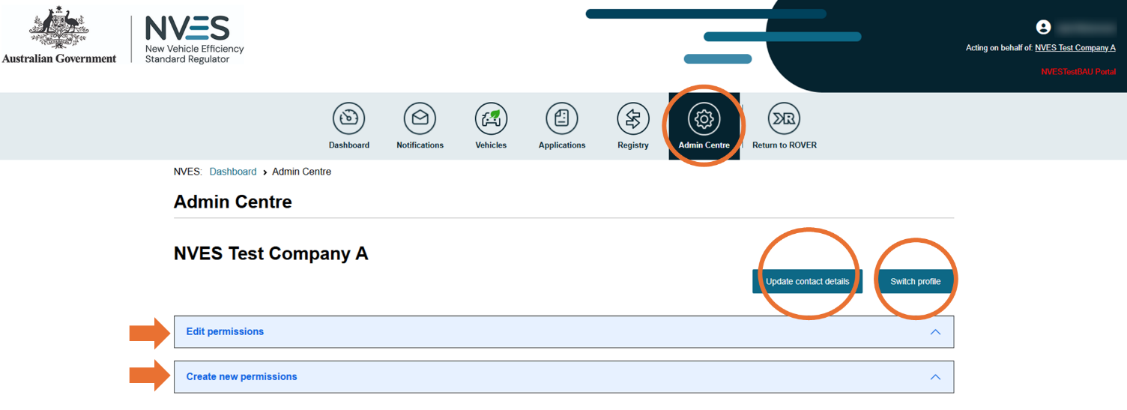
On the admin centre page, you can update contact details of the regulated entity, executive officer or an optional secondary contact, and switch profile (act for different entities).
On this page, users with a ‘Registry Admin’ role can give permissions to other users and manage permissions of existing authorised users, including closing their own user account.
If you provide a secondary contact for an entity, then email notifications will also be sent to the entity’s secondary contact.

Update your Executive Officer contact details
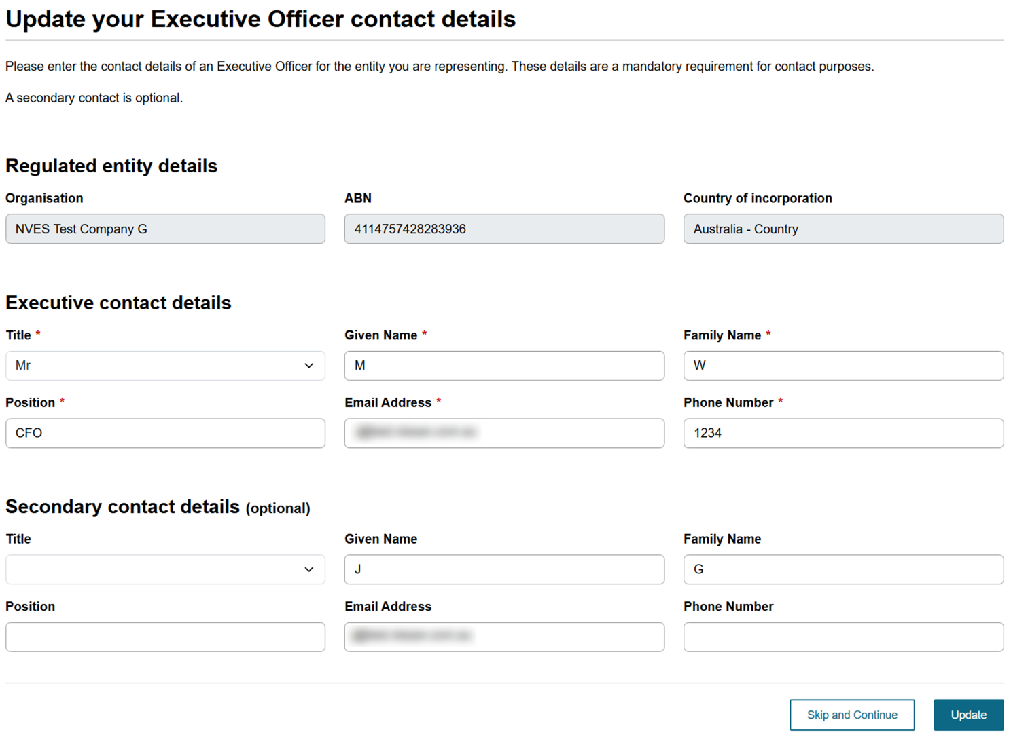

Manage account permissions of an existing user
Users with a ‘Registry Admin’ role of an approved registry account can create new permissions for an existing user with an authority to act for the regulated entity. The permission has a start date and an optional end date. You can assign permissions to one or more roles for the unit registry account:
- Transfer Initiator
- Transfer Authoriser
- Registry Viewer
- Registry Account Administrator.
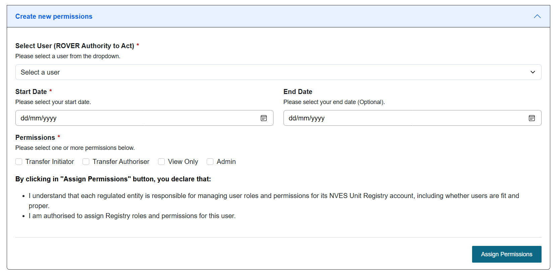
See the ROVER, portal and unit registry roles and access section on page 7 for more details.
The invitee can accept the invitation to gain access to the profile of the entity.
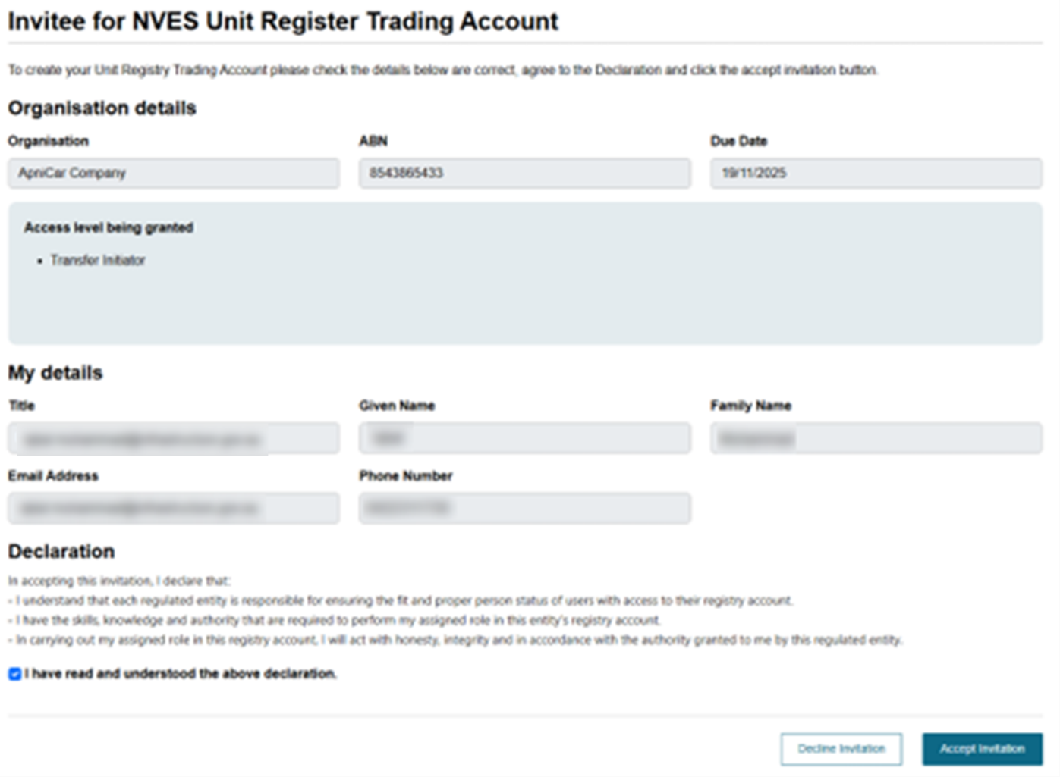
Users with a ‘Registry Admin’ role of an approved registry account can manage account permissions of existing authorised users.
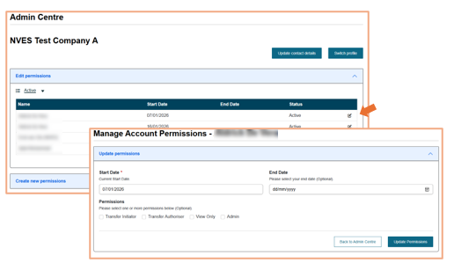

Remove NVES Unit Registry account
Users with a ‘Registry Admin’ role can also close their own user account.
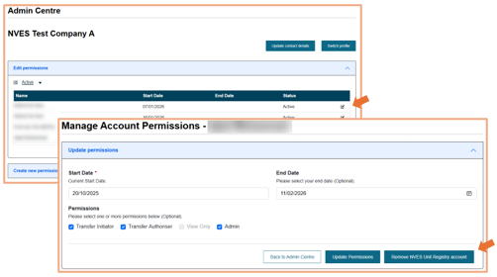
However, if the user is the only authorised user with a ‘Registry Admin’ role then a warning message will appear regarding the management of the registry permissions for the organisation.
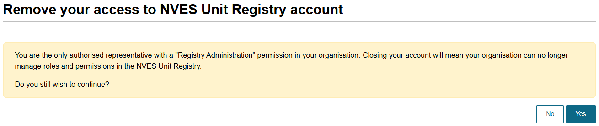

We are here to help

NVES account managers
For questions or issues with the portal or this user guide, regulated entities and their authorised users can contact their NVES Regulator account manager by:
- Email: NVESRegulator@infrastructure.gov.au
- Phone:
  - From within Australia: 1800 248 610
  - From outside Australia: +61 2 6136 9088.

ROVER support team
Regulated entities experiencing issues managing authority to act permissions or ROVER can contact the department’s ROVER support team by:
- Email: ROVERinfo@infrastructure.gov.au
- Phone:
  - From within Australia: 1800 815 272
  - From outside Australia: +61 2 6136 8006.

More information
Visit our online systems webpage to learn more about the portal and NVES related systems.

Document Control
Refer to the below table for the information on versions of this document.
Version | Release date | Reason for update
1.0 | September 2025 | Initial release of document for NVES Portal release 1, which included how entities:  - apply to open a unit registry account, including submitting their FPP declaration  - view their NVES vehicle data as entered on the Register of Approved Vehicles (RAV)  - view their emissions performance over time (referred to as their rolling emissions value)  - view requests for information from us.
1.1 | October 2025 | Update for NVES Portal release 2.1 on how:  - entities can access the new ‘Admin Centre’ in the portal allowing them to:  - update their Executive Officer details and secondary contact details for their organisation  - switch profiles (if they act on behalf of more than one regulated entity)  - update/give unit registry permissions to other users (only for a unit registry account).
1.2 | December 2025 | Update to fit and proper person content.
1.3 | January 2026 | Update for NVES Portal release 3.1 on how:  - we can issue interim emissions values (IEVs) and any associated units to entities from February 2026.  - entities can manage (transfer or extinguish) their units from February 2026  - entities can self-manage their unit registry permissions through the portal dashboard.
1.4 | February 2026 | Minor updates for NVES Portal release 3.2
1.5 | April 2026 | Update for NVES Portal release 4 on how entities:  - can apply for additional units post interim emissions value (IEV) issuance through the portal where they have an approved correction for a Register of Approved Vehicles (RAV) entry.  - All applications must be supported by appropriate evidence or they won’t be accepted.  - will receive notifications to help them manage their NVES compliance activities.  - can more easily manage their obligations by:  - being able to upload documents in respond to a request for information (RFI) directly  - accessing more information on unit transactions, emissions performance and unit expiration.
1.6 | June 2026 | Update for NVES Portal release 5 to include content on how a registry account admin can close their own user account in the Admin Centre of the portal.
1.7 | August 2026 | Minor updates to the section on applying for a unit registry account.
1.8 | August 2026 | Minor update to the section on downloading a reconciliation report

